APPEAL PROCESS WORKSHOP
SAJAD SHAKOOR

- Introduction
  - Bio
  - Tayba Foundation explained
- Regulations that govern CDCR
  - Title 15
  - Dom
  - Op
  - Memo
- How title 15 is constructed
  - Noice of register
  - Initial_Statement_of_Reasons
  - Notice_of_Change_to_Regulations_14-02
  - Notice_of_Proposed_Regulations
  - Text_of_Proposed_Regulations
- What you can appeal

- CDCR-Forms
  - Form-22 informational pamphlet
  - Form-22
  - Form 602 informational pamphlet
  - Form 602
  - Definitions
  - Time limits
- Appeal preparation
  - Right to appeal
  - Supporting documents
  - Appeal system abuse
- Appeal process
  - Screening and managing appeals
  - Level of appeal review and disposition
  - Rejection, cancellation, withdrawal
  - Exceptions to the process
- Solano sample packet
  - The appellant
  - Notoriety of case
  - Form 22
  - 602/ 602-A/ 602-G
  - Appeals Coordinator responses
  - Appellant letter to warden
  - Third level response
  - Supporting documents

Sajad Shakoor Bio

Sajad Shakoor grew up as a troubled teen. Picked on in school, he suffered from lack of self-esteem and found it extremely difficult to realize his self-worth. He started associating with gang members and participating in destructive lifestyles, which, inevitably, resulted in a six-year prison sentence while still a teenager. A year after his release and with no education or marketable skills, he found himself gravitating towards those same destructive lifestyles and being sentenced to 25-to-life in prison under California's “three strikes” law. However, that time would change his life, embarking on an extensive process of introspection and self-reform, recognizing his potential, pursuing his education, and eventually graduating from Ohio University. This not only transformed him as an individual, but also paved the way for his release. He is now pursuing a doctorate in education at the Western Institute in Berkeley, California, and is employed as a teacher at the Tayba Foundation, a distance-learning program for prisoners.

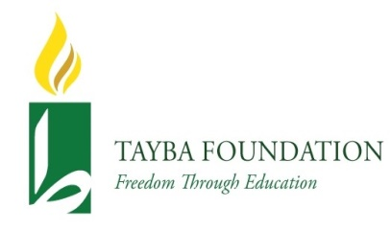
Tayba Foundation is a registered 501 (c)(3) that provides current and formerly incarcerated men and women with educational that are geared towards the refinement of their thinking and behavior. We want our students to be ready to transition to society more productively. We provide correspondence courses at the postsecondary level to the incarcerated and formerly incarcerated through our Distance Learning Program. We also support inmates who pursue their education through other distance learning programs. We’ve seen the transformative value of higher education and are wholeheartedly committed to establishing the processes that enable our students to inherit a contributory role that will facilitate their self-improvement and allow them to reclaim a future, even beyond the walls of the prison

MODULE 1

Regulations that govern CDCR
- Title 15
- Dom
- Op
- Memo

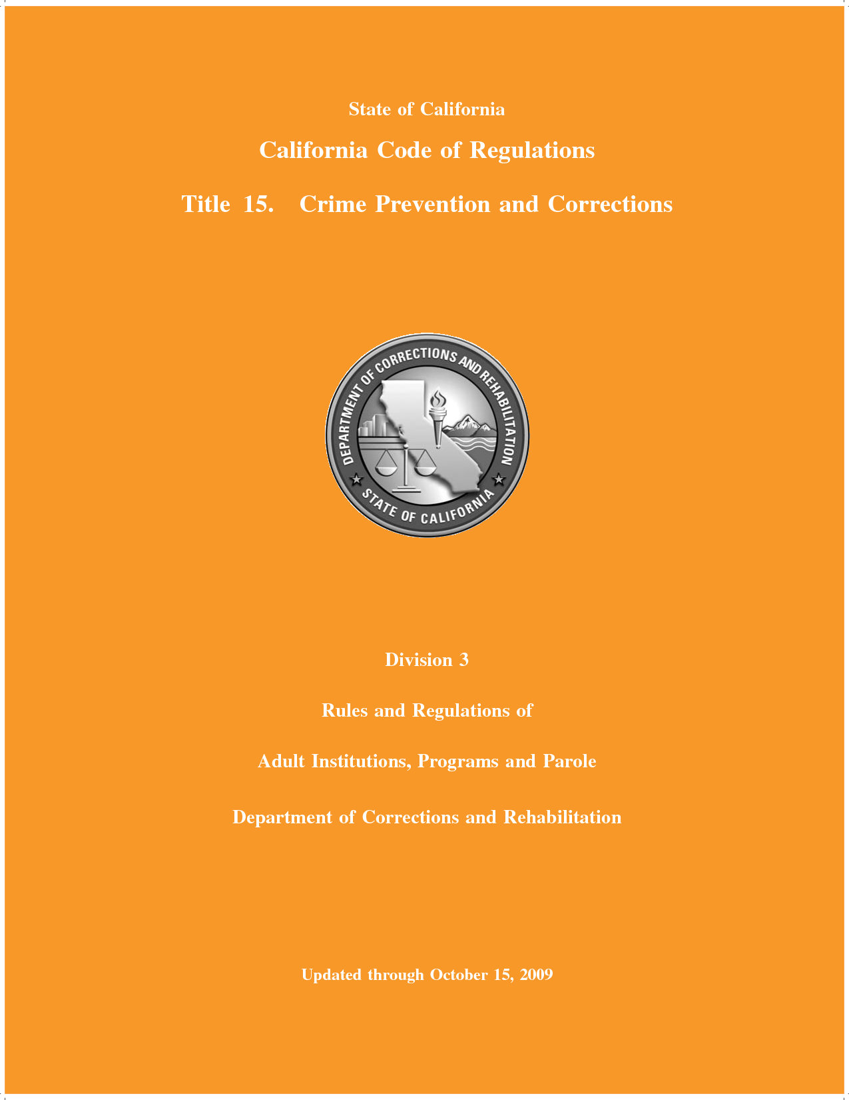

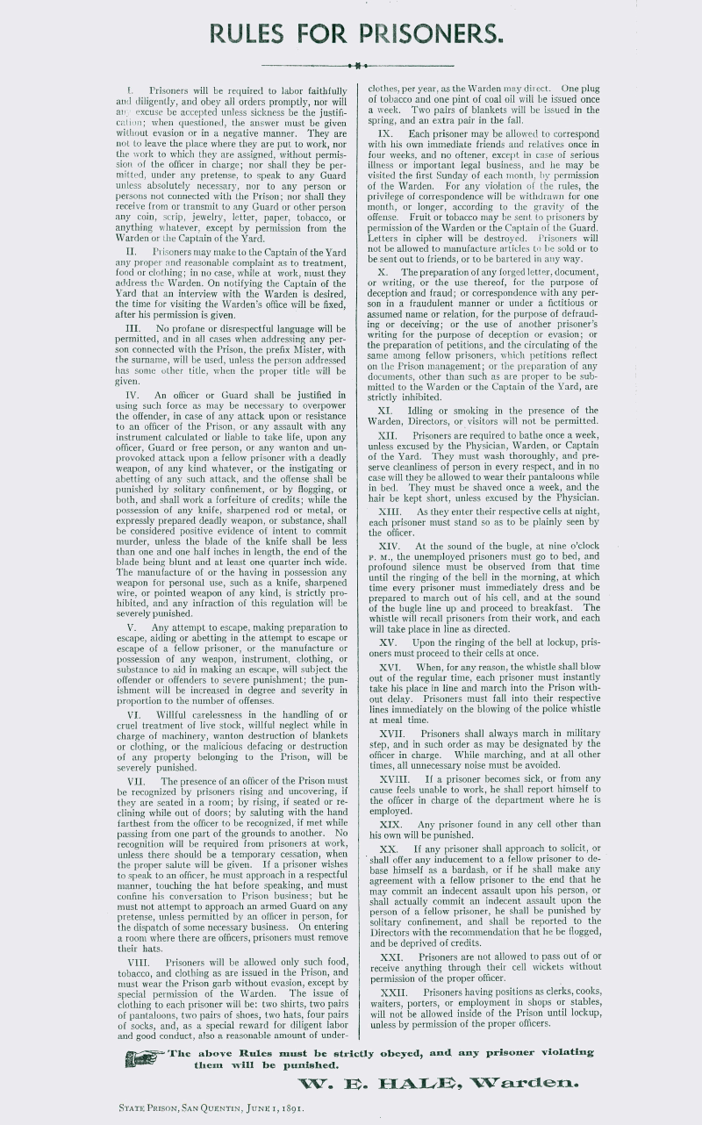
San Quentin rules 110 years ago
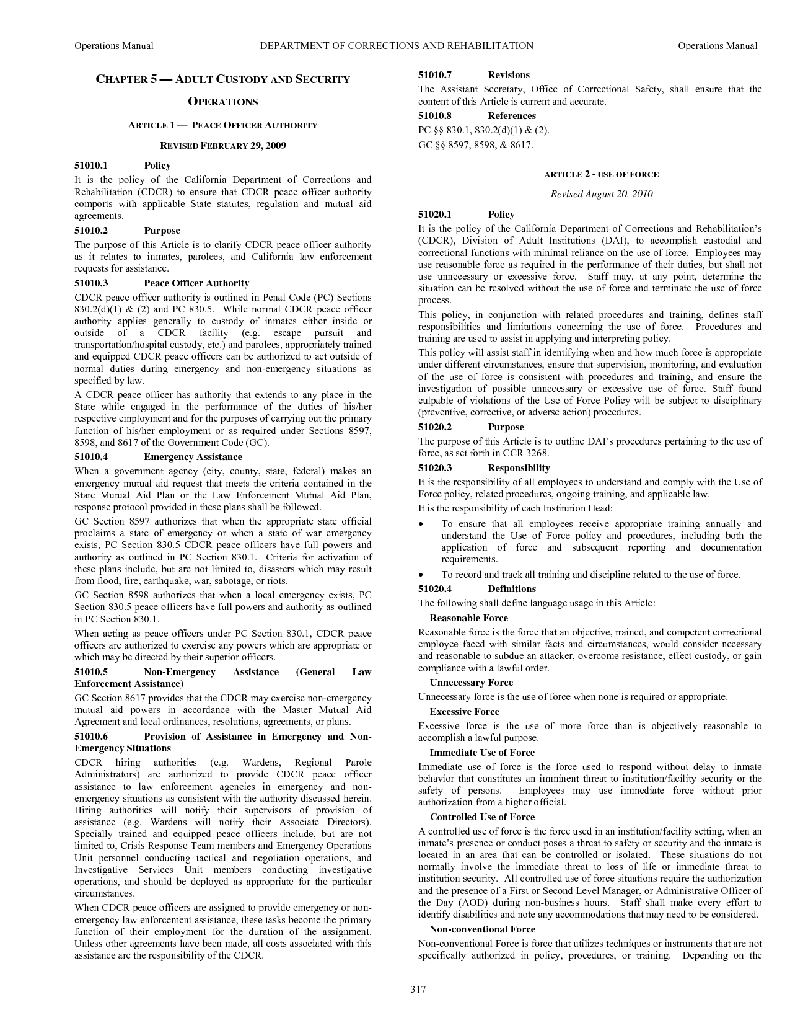
Copy of the Department Operations Manual
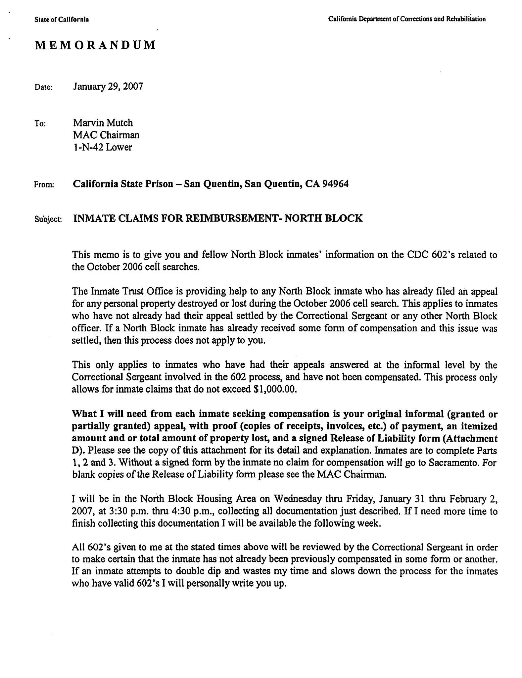

MODULE 2

How title 15 is constructed
  - Noice of register
  - Initial_Statement_of_Reasons
  - Notice_of_Change_to_Regulations_14-02
  - Notice_of_Proposed_Regulations
  - Text_of_Proposed_Regulations

MARCH 15, 2013
PUBLISHED WEEKLY BY THE OFFICE OF ADMINISTRATIVE LAW
REGISTER 2013, NO. 11–Z
OFFICE OF ADMINISTRATIVE LAW
EDMUND G. BROWN, JR., GOVERNOR

PROPOSED ACTION ON REGULATIONS
TITLE 2. FAIR POLITICAL PRACTICES COMMISSION
Conflict of Interest Code — Notice File No. Z2013–0305–10 . . . . . . . . . . . . . . . . . . . . . . . . . . . . . . . . . . . . . . . . . . . . 415
Adoption
State Agency: Citizens Redistricting Commission
TITLE 2. PUBLIC EMPLOYEES’ RETIREMENT SYSTEM
Public Employees’ Pension Reform Implementation — Notice File No. Z2013–0305–11 . . . . . . . . . . . . . . . . . . . . . . 416
TITLE 3. DEPARTMENT OF FOOD AND AGRICULTURE
Asian Citrus Psyllid Interior Quarantine — Notice File No. Z2013–0305–06 . . . . . . . . . . . . . . . . . . . . . . . . . . . . . . . 419
TITLE 8. WORKERS’ COMPENSATION APPEALS BOARD
WCAB Rules of Practice and Procedure — Notice File No. Z2013–0305–02 . . . . . . . . . . . . . . . . . . . . . . . . . . . . . . . 422
TITLE 14. DEPARTMENT OF RESOURCES RECYCLING AND RECOVERY
Form 303 Household Hazardous Waste Collection Report — Notice File No. Z2013–0305–12 . . . . . . . . . . . . . . . . . 424
TITLE 15. DEPARTMENT OF CORRECTIONS AND REHABILITATION
Inmate Religious Property — Notice File No. Z2013–0301–01 . . . . . . . . . . . . . . . . . . . . . . . . . . . . . . . . . . . . . . . . . . 427
TITLE 16. BOARD OF BEHAVIORAL SCIENCES
Examination Restructure — Notice File No. Z2013–0305–05 . . . . . . . . . . . . . . . . . . . . . . . . . . . . . . . . . . . . . . . . . . . 429
TITLE 16. DENTAL BOARD OF CALIFORNIA
Uniform Standards for Substance Abusing Licensee — Notice File No. Z2013–0305–03 . . . . . . . . . . . . . . . . . . . . . . 434

GENERAL PUBLIC INTEREST
CALIFORNIA ENVIRONMENTAL PROTECTION AGENCY
Notice of Change of Date of Regulatory Hearing and Extension of Written Comment Period re: Unified Program, Title 27, Sections 15100–15620 and Data Dictionary Elements . . . . . . . . . . . . . . . . . . . . . . . . 441 (Continued on next page)
TimeDated
Material
DEPARTMENT OF FOOD AND AGRICULTURE
Notice of Proposed Rulemaking Address Information for Rulemaking File Location . . . . . . . . . . . . . . . . . . . . . . . . . 441
DEPARTMENT OF HEALTH CARE SERVICES

INITIAL STATEMENT OF REASONS:

The California Department of Corrections and Rehabilitation (CDCR or the Department) proposes to amend the California Code of Regulations, Title 15, Division 3, Sections 3000, 3023, 3043.4, 3044, 3077, 3139, 3269, 3269.1, 3314, 3315, 3321, 3323, 3334, 3335, 3341.5, 3375, 3375.2, 3375.3, 3376, 3376.1, 3377.2, 3378, 3378.1, 3378.2, 3378.3, 3504, 3505, 3545, 3561, 3651 and 3721 and to adopt Sections 3378.4, 3378.5, 3378.6, 3378.7, 3378.8 and 3378.9 concerning changes to the Department’s Gang Management policy.
The management of gangs nationally in both communities and custodial settings has created an enormous challenge for law enforcement agencies. Gangs jeopardize public safety as they facilitate violence, drug trafficking, extortion and create substantial harm in prisons, jails and local communities. Managing criminal gangs requires a comprehensive strategy to identify involved gang members, target interdiction strategies, and remove their threat towards others.
CDCR historically has approached gang identification and management through intervention and suppression strategies and has been successful in reducing the impact sophisticated gang members have in CDCR facilities. To combat gangs, CDCR has identified the gangs with the greatest propensity for violence and has separated the affiliated offenders from the general population by placing them into a Security Housing Unit (SHU) environment. Currently, these gangs are referred to as prison gangs as they have originated and have their roots in the CDCR or another prison system. Within the new policy, prison gangs, street gangs, and disruptive groups will be referred to as Security Threat Groups (STG). This is a term that is used in the Federal Correctional system and in many other states across the nation.
Despite the successes the CDCR has had in removing violent and disruptive STG affiliates from the general population settings of the institutions, the Department has recognized a need to evaluate current strategies and implement new approaches to address evolving STG trends consistent with security, fiscal, and offender population management needs. Fortunately, the inmate population reductions associated with Public Safety Realignment is affording CDCR the opportunity to reconstruct aspects of its STG policy that are consistent with successful models used in other large correctional agencies. The Public Safety Realignment will result in easing overcrowding and providing CDCR with more housing options to support this effort.
CDCR’s regulatory policy for identifying STG members and associates and separating them from the general population will be replaced with a model that identifies, targets and manages STGs leadership and activities and utilizes a behavior based “Step Down” Program (SDP). This program will afford offenders the opportunity to work their way from a restricted program back to a general population setting by demonstrating a willingness and commitment to discontinue STG related activity while in a CDCR facility. In addition, STG associates will no longer be considered for direct administrative placement into a SHU based only upon their validation, unless there exists corresponding confirmed disciplinary behavior with an STG nexus. Members of the most dangerous groups (STG-Is) will be considered for placement in SHU after confirmation of their validation by ICC.
In developing these proposed regulations the Department consulted a variety of stakeholders, including prisoner advocacy organizations Background
CDCR manages arguably the most violent and sophisticated STG members and associates in the nation. California STGs are routinely and consistently connected to major criminal activities in communities, including such crimes as homicides, drug trafficking, prostitution, human trafficking, and extortion. As such, the responsibility and challenges facing CDCR relative to the management of STGs are immense.
STG problems throughout the country have grown more serious in both the local communities and correctional settings. STGs are largely responsible for criminal activities within the institutions, to include the trafficking of narcotics, committing and/or directing violence against staff and offenders, and directing criminal activity between the correctional institutions and the community.
Prisons are especially vulnerable to internal disruption by STG affiliates who, through their violent nature, routinely victimize each other, uninvolved offenders and staff, in addition to creating heavy demands on personnel and fiscal resources.
Efficient and effective STG management within prisons requires a comprehensive STG prevention, identification, and management policy that include interdiction and rehabilitation. CDCR’s regulatory strategy, which was initially developed more than 25 years ago, is that of a crime prevention strategy through suppression. The Department recognizes a need to evaluate those strategies and adopt new approaches to addressing constantly evolving STG trends.
This new STG policy introduces a comprehensive strategy designed to:
- Provide graduated housing with increased program and privileges based on positive programming, as well as, consequences for non-compliance associated with STG related behaviors.
- Enable an offender to engage in reintegration from a SHU environment back to general population or sensitive needs yard (SNY) through a SDP.
- Support and educate offenders desiring to disavow and/or disengage from the STG lifestyle.
- Prevent or reduce STG influence and STG violence.
- Provide additional levels of due process in the validation process.
- Promote safe and efficient prison operations.
- Weaken the organization and communication of the STG through intelligence and behavior based management strategies.
- Curtail the ability of STGs to participate in crimes that transcend the boundaries of the institution into the community.
- Provide programs designed to promote social values and behaviors in preparation for the offenders’ return to the community.
Essential to achieving these goals is the continuing evolution of our existing intelligence network to identify and document STG related activities/behaviors and track STG trends. A sound strategy supported by reliable intelligence will enhance the prison managers’ ability to anticipate, prevent, respond and control STG problems proactively rather than relying on defensive or reactive means of suppression and intervention.
This policy includes an enhanced intelligence based identification system needed to identify members, associates, and suspects who are believed to present a clear threat to the safety of staff, offenders, and the security of the institutions. This, in association with documented STG related behavior will provide prison managers the necessary information to make decisions regarding the appropriate housing and program needs for the offender. This policy supports the CDCR strategic plan through effective classification of offenders and placement of the right offender, in the right program, at the right time.
The policy changes are based on recommendations made by subject matter experts within the CDCR as well as consideration of strategies and best practices used by agencies outside of California. This complex retooling of CDCR’s STG management strategy will require significant changes to regulations, practices, and institutional culture to ensure success. Any change of this magnitude and its associated potential risk must be done thoughtfully, methodically and deliberately. The policy will support California’s efforts toward establishing a updated model of managing STGs in a prison environment.
Although several correctional systems employ similar strategies, there is no one “best practice”. Success of any STG strategy requires an objective evaluation of specific STG dynamics and development of methods to meet these needs. Operational strategies and methods of carrying them out must be systematically integrated. Of particular importance is the development of STG policies that differentiate between STG and non-STG related behaviors and their seriousness for particular correctional programs. The Department believes that this policy recognizes the distinction between these behaviors.

Litigation

Castillo vs. Alameida: Castillo’s original lawsuit was filed in August 1994. Plaintiff challenged the constitutionality of the STG validation procedures; the evidence used in his individual validation; and whether or not his validation was the result of retaliation by prison officials for his jailhouse lawyering and peace proposal activities. Plaintiff also challenged some of the physical conditions in the SHU at PBSP, as well as the psychological effects of long-term SHU confinement, which was dismissed on summary judgment in January 2004.

A Settlement Agreement was reached in September 2004 which outlined the following due process procedures to be provided to each offender at the pre-validation and inactive review stage. CDCR will provide the offender with at least 24-hour advanced notice of the source items being relied upon for validation. CDCR will record the offender’s opinion on each of the source items and forward in written form along with the validation package to OCS. A copy of the written document will be provided to the offender before being sent to OCS. Reliance on specific source items would be modified and/or better articulated. CDCR agreed that a single, STG-related incident or conduct that is described or documented by multiple sources, confidential or otherwise, shall constitute one source item only. CDCR agreed that exclusive reliance on hearsay from a confidential source will not be used as a source item for validation. Lastly, the Department agreed that an offender would not receive an SHU term as a validated STG member or associate without first being found to be a current, active STG member or associate consistent with the procedural safeguards established in the Settlement Agreement.

In adopting these new STG management policies and proposed regulations, the Department continues to adhere to the legal standards set forth in such cases.

Anticipated Benefits

The Department anticipates that these regulations will help to reduce STG (gang) violence and activity within California prisons, and eventually help to reduce gang violence in communities as well. The criminal activities of prison STGs extend beyond prison walls into many local communities, and STGs are often associated with, and in some cases control, street gangs.

The proposed regulations provide for additional due process in the procedures used to “validate” inmates as affiliates of STGs. This should help to reduce expensive litigation, as inmates will have the opportunity to challenge their validation through the Department’s processes rather than relying on the courts.

Determinations of Impact on Business and Small Business
The Department has made an initial determination no reasonable alternatives to the regulations have been identified or brought to the attention of the Department which would lessen any adverse impact on small business.
The Department has made an initial determination the action will not have a significant adverse economic impact on business. Additionally, there has been no testimony or other evidence provided that would alter the Department’s initial determination. The proposed regulations affect the internal management of prisons only, and place no requirements or restrictions on businesses.

ECONOMIC IMPACT ASSESSMENT
The Department has determined the proposed regulations will have no impact on the creation or elimination of jobs within the state. The proposed regulations affect the internal management of prisons only.
The Department has determined the proposed regulations will have no impact on the creation of new businesses or the elimination of existing businesses within California. The proposed regulations affect the internal management of prisons only, and place no requirements or restrictions upon businesses.
The Department has determined the proposed regulations will have no impact on the expansion of businesses currently doing business in California. The proposed regulations affect the internal management of prisons only, and place no requirements or restrictions on businesses.
The Department has determined the proposed regulations may benefit the health and welfare of California residents by reducing gang activity in local communities. The Department has determined the proposed regulations will have no impact on worker safety or the state’s environment as they affect the internal management of prisons only.

REPORTS, STUDIES, AND DOCUMENTS RELIED UPON

The policy changes that form the basis for these proposed regulations are founded on recommendations made by subject matter experts within CDCR as well as consideration of strategies and practices used by agencies outside of California. Although there are similarities in the field of STG management amongst correctional jurisdictions, there is not a nationally recognized “best practice”, due in large part to disparities in STG traits, evolution, violence, sophistication, establishment, influence, and size within each jurisdiction.

As a result, CDCR did not rely wholly on any single report, policy, or practice in its entirety; but instead considered them in light of the inherently unique characteristics of California’s STG population and penological system. The following research studies and policies were considered by a combined group of correctional experts in developing these proposed regulations for managing STGs in California prisons. Therefore, only relevant elements and components of the following reports, studies, and procedures have been relied upon in creating the proposed policy changes:

- Vohryzek-Bolden, Miki, Security Threat Group Identification and Management, California State University, Sacramento (CSUS) Division of Criminal Justice, 2007

- Vohryzek-Bolden, Miki, National Best Practices to Address Prison Violence, CSUS Division of Criminal Justice, March 2011

- Vohryzek-Bolden, Miki, Overview of California Department of Corrections and Rehabilitation Policies and Procedures: Gang Management, Lockdown Protocols, and Secure Housing Placement, CSUS Division of Criminal Justice, January 2011

- Vohryzek-Bolden, Miki, Recommendations to the California Department of Corrections and Rehabilitation to Address Violence in Male Prisons, CSUS Division of Criminal Justice, June 2011

- Settlement Agreement, Castillo v. Alameida, Jr. et al, United States District Court
Northern District of California, Case No C-94-2847-MJJ-JCS http://www.courts.ca.gov/opinions/revpub/F059511.PDF

- Arizona Department of Corrections, Department Order Manual: Security Threat Groups
(STGs), Department Order 806, November 2009 http://www.azcorrections.gov/Policies/800/0806.pdf

- Colorado Department of Corrections, Security Threat Administrative Review Program, RN 600-07, November 1, 2011

- Connecticut Department of Correction, Administrative Directive: Security Risk Groups,
Directive Number 6.14 http://www.ct.gov/doc/LIB/doc/PDF/AD/ad0614.pdf

- Federal Bureau of Prisons, Special Management Units, Policy Statement No. P5271.01,
November 2008
http://www.bop.gov/policy/progstat/5217_001.pdf
- Mississippi Department of Corrections, Security Threat Group Management, 16-19 (0501-09) and 16-19-01 (11-04-11); Security Threat Group Management, Movement of Leaders, 16-19-03 (02-01-07); and Security Threat Group Management-Renunciation Program, 16-19-07 (06-01-11)

- New Mexico Corrections Department, CD No. 143000: Prison Security Levels V and VI,
June 2012 and CD No. 143001: Criteria, Placement, and Review, June 2012 http://corrections.state.nm.us/policies/docs/CD-143000.pdf

- Ohio Department of Rehabilitation and Correction, Level 5 Classification, April 2012

Copies of these documents are available for review as a part of the rulemaking file.

ALTERNATIVES CONSIDERED

- Take No Action

CDCR remains committed to its mission of rehabilitation of offenders without sacrificing the safety of inmates, staff, its institutions, or the community. Taking no action and retaining existing regulations would leave validated STG members and associates without a definitive method to demonstrate their commitment and willingness to refrain from STG behavior through individual accountability and participation in rehabilitative efforts, in spite of their status. Taking no action would also provide no process for reintegration of an inmate from segregated housing to a general population setting, and such incremental reintegration is necessary for a successful transition to general population, or similarly in preparation for an inmate’s potential release back to a community setting. It is also hoped that this new stepped approach to reintegration will reduce in-prison recidivism.

- Eliminating STG SHU Sentences

To eliminate STG SHU sentences would result in the automatic return to the general population of inmates who continue to exhibit violent behavior, orchestrate others to commit violence and other crimes within the institution, across institutions, and in the community thereby endangering the safety of others. Further, the assessment of STG SHU sentences for validated inmates is reserved for those who have proven that they cannot reside in the general population with others. Therefore, CDCR would be derelict in its constitutional duty to keep safe those who are committed in its care if it eliminated such STG SHU sentences and knowingly housed without restrictions those inmates, determined through established processes and audits to pose a significant threat to others.

However, despite the nature of the initial housing assignment to the SHU, inmates are able to earn release to general population within 4 years of that initial assignment, and perhaps in as few as three years. They are able to do so by establishing through their conduct and participation that they can program with others without resorting to STG behavior.
- Further Reducing the Length of the Step Down Program

The proposed regulations will incorporate a 2 – 3 year reduction in the length of time served in SHU for an STG affiliate who previously would only be considered for release during a 6 year revolving Departmental Review Board review process.

In order to ensure successful reintegration of a validated SHU inmate into the general population he or she must first demonstrate through behavior and participation that he or she no longer poses a serious threat to the safety of others or the security of the institution. The most violent and sophisticated STGs have evolved through highly covert operations. Therefore, the readiness and willingness of an STG member or associate to reintegrate into a general population setting without posing a threat to those around him/her cannot truly be ascertained in a further shortened period of time.

Success of any STG strategy requires an objective evaluation of specific STG dynamics and development of methods to meet those needs. Therefore, these proposed regulations provide a Step Down Program through which conduct and participation can be demonstrated over the course of 4 years, which is a 30% reduction in the minimum review period for release/ inactive reviews previously utilized under Title 15. Further, inmates are given comprehensive reviews every six months and have the ability to accelerate their program in Steps 1 and 2 by a total of 1 year, thereby reducing the length of the program to 3 years, which is a 50% reduction in the previous inactive review period previously utilized.

Any further reduction in the length of the Step Down Program cannot be realized at this time without jeopardizing the safety and security of the institution.
SPECIFIC PURPOSE OF EACH SECTION PER GOVERNMENT

 | Department of Corrections and Rehabilitation  NOTICE OF CHANGE TO  REGULATIONS  Section(s): 3000, 3023, 3043.4, 3044, 3077, 3139,  3269, 3269.1, 3314, 3315, 3321, 3323, 3334, 3335,  3341.5, 3375, 3375.2, 3375.3, 3376, 3376.1,  3377.2, 3378, 3378.1, 3378.2, 3378.3, 3378.4,  3378.5, 3378.6, 3378.7, 3378.8, 3378.9, 3504,  3505, 3545, 3561, 3651, and 3721 | Number:  14-02
Publication Date:
January 31, 2014
Effective Date:
To Be Announced

INSTITUTION POSTING REQUIRED
This Notice announces the amendment of Sections 3000, 3023, 3043.4, 3044, 3077, 3139, 3269, 3269.1, 3314, 3315, 3321, 3323, 3334, 3335, 3341.5, 3375, 3375.2, 3375.3, 3376, 3376.1, 3377.2, 3378, 3378.1, 3378.2, 3378.3, 3504, 3505, 3545, 3561, 3651 and 3721 and the adoption of Sections 3378.4, 3378.5, 3378.6, 3378.7, 3378.8 and 3378.9 of the California Code of Regulations (CCR), Title 15, Crime Prevention and Corrections, to incorporate into the CCR provisions concerning Security Threat Groups (formerly referred to as prison gangs).

IMPLEMENTATION: To Be Announced PUBLIC COMMENT PERIOD
Any person may submit written comments about the proposed regulations to the California Department of Corrections and Rehabilitation, Regulation and Policy Management Branch (RPMB), P.O. Box 942883, Sacramento, CA 94283-0001, by fax to (916) 324-6075, or by e-mail to m_STGRegulation@cdcr.ca.gov. All written comments must be received by the close of the public comment period on April 3, 2014, at 5:00 p.m.

PUBLIC HEARING INFORMATION
A public hearing regarding these proposed regulations will be held Thursday, April 3, from 8:00 AM to 12:00 PM in the East End Complex Auditorium located at 1500 Capitol Avenue, Sacramento CA. The purpose of the hearing is to receive oral comments about this action. It is not a forum to debate the proposed regulations. No decision regarding the permanent adoption of these regulations will be rendered at this hearing. Written or facsimile comments submitted during the prescribed comment period are given the same significance and weight as oral comments presented at the hearing. This hearing site is accessible to the mobility impaired.

POSTING
This notice shall be posted immediately upon receipt at locations accessible to inmates, parolees, and employees in each Department facility and field office, not later than five calendar days after receipt. Also, facilities shall make this Notice available for review by inmates in segregated housing who do not have access to the posted copies, and shall distribute it to inmate law libraries and advisory councils. Certification of Posting, CDCR Form 621-A, shall be returned to the RPMB electronically, by fax, or by mail. See Department Operations Manual sections 12010.5.7 and 12010.5.8 for posting and certification of posting procedures.

CONTACT PERSON
Inquiries regarding this notice should be directed to Timothy M. Lockwood, Chief, RPMB, California Department of Corrections and Rehabilitation, P.O. Box 942883, Sacramento, CA 94283-0001, by telephone at (916) 445-2269 or e-mail at RPMB@cdcr.ca.gov. Inquiries regarding the subject matter of these regulations may be directed to Nancy Hardy, Division of Adult Institutions, at (916) 324-0791.
Original Signed By:
DIANA TOCHE
Undersecretary (A), Administration and Offender Services
California Department of Corrections and Rehabilitation Attachments

CDCR 1189 (REV. 05/09)

NOTICE OF PROPOSED REGULATIONS

California Code of Regulations
Title 15, Crime Prevention and Corrections
Department of Corrections and Rehabilitation

NOTICE IS HEREBY GIVEN that the Secretary of the California Department of Corrections and Rehabilitation (CDCR or the Department), pursuant to the authority granted by Government Code Section 12838.5 and Penal Code (PC) Section 5055, and the rulemaking authority granted by PC Section 5058, in order to implement, interpret and make specific PC Section 5054, proposes to amend Sections 3000, 3023, 3043.4, 3044, 3077, 3139, 3269, 3269.1, 3314, 3315, 3321, 3323, 3334, 3335, 3341.5, 3375, 3375.2, 3375.3, 3376, 3376.1,
3377.2, 3378, 3378.1, 3378.2, 3378.3, 3504, 3505, 3545, 3561, 3651 and 3721 and to adopt Sections 3378.4, 3378.5, 3378.6, 3378.7, 3378.8 and 3378.9 of the California Code of Regulations (CCR), Title 15, concerning Security Threat Groups (formerly referred to as prison gangs).

PUBLIC HEARING:
Date and Time: | April 3, 2014 - 8:00 a.m. to 12:00 p.m.
Place: | East End Complex  Auditorium  1500 Capitol Avenue  Sacramento, CA 95811
Purpose: | To receive comments about this action.

PUBLIC COMMENT PERIOD:
The public comment period will close April 3, 2014, at 5:00 p.m. Any person may submit public comments in writing (by mail, by fax, or by e-mail) regarding the proposed changes. To be considered by the Department, comments must be submitted to the CDCR, Regulation and Policy Management Branch, P.O. Box 942883, Sacramento, CA 94283-0001; by fax at (916) 324-6075; or e-mail at m_STGRegulation@cdcr.ca.gov before the close of the comment period.

CONTACT PERSON:
Please direct any inquiries regarding this action to:

Timothy M. Lockwood, Chief
Regulation and Policy Management Branch
Department of Corrections and Rehabilitation
P.O. Box 942883, Sacramento, CA 94283-0001 Telephone (916) 445-2269

In the event the contact person is unavailable, inquires should be directed to the following back-up person:

Josh Jugum
Regulation and Policy Management Branch
Telephone (916) 445-2228
Questions regarding the substance of the proposed regulatory action should be directed to:

Nancy Hardy
Division of Adult Institutions Telephone (916) 324-0791 AUTHORITY AND REFERENCE
PC Section 5000 provides that commencing July 1, 2005, any reference to the Department of Corrections in this or any code, refers to the CDCR, Division of Adult Operations.

PC Section 5050 provides that commencing July 1, 2005, any reference to the Director of Corrections, in this or any other code, refers to the Secretary of the CDCR. As of that date, the office of the Director of Corrections is abolished.

PC Section 5054 provides that commencing July 1, 2005, the supervision, management, and control of the state prisons, and the responsibility for the care, custody, treatment, training, discipline, and employment of persons confined therein are vested in the Secretary of the CDCR.

PC Section 5058 authorizes the Director to prescribe and amend regulations for the administration of prisons.

INFORMATIVE DIGEST/POLICY STATEMENT OVERVIEW:

This action will:

- Replace references in the regulations to prisons gangs, street gangs and similar disruptive groups with the term Security Threats Groups (STGs). This term is used in the Federal correctional system and in many other correctional jurisdictions.
- Amend the Department’s current STG (gang) management policy, which identifies STG members and associates and separates them from the General Population, to focus on identifying, interdicting, and managing STG leadership and behavior. The Department will move from a status-based process (i.e., gang affiliation) to a behavior-based process that separates gang affiliates from the General Population based on STG-related disciplinary violations and/or confirmed membership.
- Establish a process for the certification by the Department of a group or gang as a STG-I, and the recognition of a group/gang as a STG-II, based on criteria specified in the regulations. This process will differentiate between STG-Is, which are the more “traditional” prison type gangs that are considered the greatest threat to staff and institution security, and STG-IIs, which are other groups such as street gangs or other disruptive groups.
- Establish additional due process and a weighted criteria scalein the procedures used to validate an offender as an affiliate of an STG.
- Differentiate between STG-I Members and other offenders such as Associates who are affiliated with an STG but not a member. Only STG-I Members confirmed by an Institution Classification Committee will be placed in Security Housing Units (SHU) based on validation alone. Affiliated offenders will be placed in SHU if they have engaged in documented STG behavioral violations.
- Establish a five-step Step Down Program which will allow inmates housed in the SHU as a result of STG related behavior to return to a General Population setting provided they meet specified criteria and remain free of disciplinary violations.
- Incorporate enhanced privileges for inmates electing to participate through the Step Down Program.
- Establish a process to address classification and housing of validated STG affiliates who have paroled or discharged from CDCR jurisdiction and return to custody.
- Adopt definitions for several new terms related to Security Threat Groups and the Step Down Program.
- Incorporate into the regulations the STG Disciplinary Matrix, which will be used to determine Step Down Program placement when specified validated offenders commit STG-related disciplinary violations.
- Establish a process for the termination of an offender’s status as a validated STG affiliate when specified criteria are met.
- Establish the responsibilities of various Department staff and committees as part of the STG
policy.
FORMS INCORPORATED BY REFERENCE
CDCR 128-G1 (11/13) Security Threat Group Unit Classification Committee – Results of Hearing CDC 115 (07/88) Rules Violation Report
CDC 812 (11/13) Notice of Critical Case Information – Safety of Persons (Non-Confidential Enemies) CDC 128-B (4/74) General Chrono
Security Threat Group Certification Worksheet
CDCR 128-B3 (11/13) Security Threat Group Identification Score Sheet CDCR 128-B4 (11/13) Evidence Diclosure and Interview Notification
CDCR 1030 (11/13) Confidential Information Disclosure Form
CDCR 128- B5 (11/13) Security Threat Group Validation Chrono
CDCR 128-B2 (11/13) Security Threat Group Validation / Rejection Review
CDCR 128B SDP1 (11/13) Step Down Program Notice of Expectations (Step 1)
CDCR 128B SDP2 (11/13) Step Down Program Notice of Expectations (Step 2) CDCR 128B SDP3 (11/13) Step Down Program Notice of Expectations (Step 3)
CDCR 128B SDP4 (11/13) Step Down Program Notice of Expectations (Step 4)
CDCR 128B SDP5 (11/13) Notice of Conditions of Monitored Status CDC 128-G (10/89) Classification Chrono

SPECIFIC BENEFITS ANTICIPATED BY THE PROPOSED REGULATIONS
The Department anticipates that these regulations will help to reduce STG (gang) violence and activity within California prisons, and eventually help to reduce gang violence in communities as well. The criminal activities of prison STGs extend beyond prison walls into many local communities, and STGs are often associated with, and in some cases control, street gangs.
The proposed regulations provide for additional due process in the procedures used to “validate” inmates as affiliates of STGs. This should help to reduce expensive litigation, as inmates will have the opportunity to challenge their validation through the Department’s processes rather than relying on the courts.

EVALUATION OF CONSISTENCY / COMPATIBILITY WITH EXISTING LAWS/REGULATIONS
The Department has researched existing statutes and regulations regarding Security Threat Groups / prison gangs and has determined that these proposed regulations are not inconsistent or incompatible with existing state laws and regulations.
Currently, Department policy regarding STGs and the Step Down Program is under the authority of the STG Pilot Program, which went into effect in October 2012. This pilot program will remain in effect until these proposed regulations are permanently adopted.

LOCAL MANDATES:
This action imposes no mandates on local agencies or school districts, or a mandate which requires reimbursement of costs or savings pursuant to Government Code Sections 17500 - 17630.

FISCAL IMPACT STATEMENT:
- Cost to any local agency or school district that is required to be reimbursed: None
- Cost or savings to any state agency: None
- Other nondiscretionary cost or savings imposed on
local agencies: None
- Cost or savings in federal funding to the state: None

EFFECT ON HOUSING COSTS:
The Department has made an initial determination that the proposed action will have no significant effect on housing costs.

COST IMPACTS ON REPRESENTATIVE PRIVATE PERSONS OR BUSINESSES:
The Department is not aware of any cost impacts that a representative private person or business would necessarily incur in reasonable compliance with the proposed action.

SIGNIFICANT STATEWIDE ADVERSE ECONOMIC IMPACT ON BUSINESS:
The Department has initially determined that the proposed regulations will not have a significant statewide adverse economic impact directly affecting businesses, including the ability of California businesses to compete with businesses in other states.

EFFECT ON SMALL BUSINESSES:
The Department has determined that the proposed regulations may not affect small businesses. It is determined that this action has no significant adverse economic impact on small business because they are not affected by the internal management of state prisons.

RESULTS OF THE ECONOMIC IMPACT ASSESSMENT:
The Department has determined that the proposed regulation will have no affect on the creation of new, or the elimination of existing, jobs or businesses within California, or affect the expansion of businesses currently doing business in California. The Department has determined that the proposed regulations will have no affect on the health of California residents, worker safety, or the state’s environment, because they relate strictly to the internal management of CDCR institutions.

The Department has determined that the proposed regulations may have an indirect positive impact upon the welfare of California residents by helping to reduce gang activity in local communities.

CONSIDERATION OF ALTERNATIVES:
The Department must determine that no reasonable alternative considered by the Department or that has otherwise been identified and brought to the attention of the Department would be more effective in carrying out the purpose for which the action is proposed, would be as effective and less burdensome to affected private persons, or would be more cost-effective to affected private persons and equally effective in implementing the statutory policy or other provisions of law, than the proposed regulatory action. Interested persons are invited to present statements or arguments with respect to any alternatives to the changes proposed at the scheduled hearing or during the written comment period.

AVAILABILITY OF PROPOSED TEXT AND INITIAL STATEMENT OF REASONS:
The Department has prepared, and will make available, the text and the Initial Statement of Reasons (ISOR) of the proposed regulations. The rulemaking file for this regulatory action, which contains those items and all information on which the proposal is based (i.e., rulemaking file) is available to the public upon request directed to the Department's contact person. The proposed text, ISOR, and Notice of Proposed Action will also be made available on the Department’s website http://www.cdcr.ca.gov.

AVAILABILITY OF THE FINAL STATEMENT OF REASONS:
Following its preparation, a copy of the Final Statement of Reasons may be obtained from the Department’s contact person.

AVAILABILITY OF CHANGES TO PROPOSED TEXT:
After considering all timely and relevant comments received, the Department may adopt the proposed regulations substantially as described in this Notice. If the Department makes modifications which are sufficiently related to the originally proposed text, it will make the modified text (with the changes clearly indicated) available to the public for at least 15 days before the Department adopts the regulations as revised. Requests for copies of any modified regulation text should be directed to the contact person indicated in this Notice. The Department will accept written comments on the modified regulations for 15 days after the date on which they are made available.

California Code of Regulations, Title 15, Division 3, Adult Institutions, Programs and Parole
TEXT OF PROPOSED REGULATIONS

In the following text, strikethough indicates deleted text; underline indicates added or amended text.

3000 Definitions.

Section 3000 is amended to alphabetically merge the definitions below with those that exist in the regulations.
*
*
*
Affiliate means individual offenders validated as members, associates, or monitored status who are connected or interact with a certified or recognized Security Threat Group.

Confirmed Security Threat Group (STG) Behavior means behavior with a nexus to an STG which is discovered and confirmed to have occurred. Confirmation can be obtained through either a guilty finding in a STG related Rules Violations Report and/or any document that clearly describes the STG behavior/activities incorporated within the validation or continued STG behavior package which is affirmed by an STG Unit Classification Committee.

Debriefing is the formal process by which a Security Threat Group (STG) coordinator/investigator determines whether an offender has abandoned STG affiliation and dropped out of a STG. A subject shall only be debriefed upon their request, although staff may ask if he or she wants to debrief.

Direct Link means any connection between a subject and any person who has been validated as an STG affiliate. This connection does not need to be independently indicative of STG association beyond the requirements for validation source items listed in CCR Section 3378.

Dropout means a validated affiliate who has cooperated in, and successfully completed Phase One and Two of the debriefing process.

Gang means any ongoing formal or informal organization, association or group of three or more persons which has a common name or identifying sign or symbol whose members and/or associates, individually or collectively, engage or have engaged, on behalf of that organization, association, or group, in two or more acts which include: planning, organizing, threatening, financing, soliciting, or committing unlawful acts, or acts of misconduct outside of the California Department of Corrections and Rehabilitation jurisdiction. classified as serious pursuant to section 3315.

Inactive Status Affiliate means a validated affiliate who was released from SHU prior to implementation of the Step Down Program. This inmate was not previously identified as having been involved in gang related behavior for a period of six years, was reviewed by a Departmental Review Board and released from the Security Housing Unit.

1
Inactive-Monitored Status Affiliate means a validated affiliate who was released from the Security Housing Unit concurrent with the implementation of the Step Down Program through a Departmental Review Board hearing.

Monitored Status Affiliate means any offender who has successfully completed Steps 1-4 in the Step Down Program and has been released from a Security Housing Unit.

Offender means any inmate, ward, parolee, or other person currently under the jurisdiction of the CDCR.

Prison Gang means any gang which originated and has its roots within the department or any other prison system. Credit earning for validated prison gang members and associates housed in Administrative Segregation Units (ASU), Security Housing Units (SHU), Psychiatric Services Units (PSU), or Behavior Management Units (BMU) as referenced in Penal Code Section 2933.6 shall apply to inmates validated as STG-I member or associates who are housed in ASU, SHU, PSU, or BMU.

Security Threat Group (STG) means any ongoing formal or informal organization, association, or group of three or more persons which has a common name or identifying sign or symbol whose members and/or associates, individually or collectively, engage or have engaged, on behalf of that organization, association or group, in two or more acts which include, planning, organizing, threatening, financing, soliciting or committing unlawful acts, or acts of misconduct.

Security Threat Group I (STG-I) is a term used to identify and prioritize the level of threat the group presents that affects the safety and security of the institution and public safety. STG-I designation will be reserved for STGs that pose the greatest of these threats. STG-I designation will include, but may not be limited to, traditional prison gangs or similar disruptive groups or gangs that the department has certified to have a history and propensity for violence and/or influence over subservient STGs.

Security Threat Group II (STG-II) is a term used to identify and prioritize the level of threat the group presents that affects the safety and the security of the institution and public safety. The STG-II designation may include, but is not limited to, traditional disruptive groups/street gangs.

Security Threat Group Administrative Directive is an administrative order, approved by the Secretary (or designee) of the CDCR, certifying a group’s threat to the safety of staff, offenders, and the security of the institution based on a documented history of, and future propensity for violence.

Security Threat Group (STG) Associate means any offender or any person who, based on documented evidence, is involved periodically or regularly with the members of a STG. STG Associates will be identified through the validation process.

Security Threat Group (STG) Behavior is any documented behavior that promotes, furthers, or assists a STG. This includes, but is not limited to conduct of any person that leads to and includes the commission of an unlawful act and/or violation of policy demonstrating a nexus to a STG.

Security Threat Group (STG) Member means any offender or any person who, based on documented evidence, has been accepted into membership by a STG. STG Members will be identified through the validation process.

Security Threat Group (STG) Suspect means any offender or any person who, based on documented evidence, is involved periodically or regularly with the members or associates of a STG. The STG suspect is tracked by STG Investigative staff pending validation. Suspects have attained more than one but less than ten points of validation as described in Section 3378.2(b).

Security Threat Group (STG) Unit Classification Committee is a unit classification committee responsible for making the determination of an inmate’s validation status, reviewing Dropout status affiliate’s new disciplinary behavior to determine nexus to STG, and reviewing information/intelligence regarding inmate-involved incidents occurring outside CDCR jurisdiction to ensure disciplinary processes and/or formal documentation were applied.

Step Down Program (SDP) is a five-step program that provides inmates placed in a Security Housing Unit (SHU) due to STG validation and/or documented STG behaviors, with a program expectation of discontinuing participation in STG related activities and includes increased incentives to promote positive behavior with the ultimate goal of release from the SHU.

Step Down Program, Step 1 and 2 SHU means the first two of five steps in the step down process designated for housing of STG affiliates determined to pose the greatest threat to the safety of staff, inmates, and the public, in addition to the security of the prison based upon intelligence and/or confirmed STG behaviors. Steps 1 and 2 are designed to be completed in 12 months each, but may be accelerated at the 180 day review.

Step Down Program, Step 3 and 4 SHU are steps in the five-step program intended to begin reintegration of the STG affiliates by offering program and privilege incentives within a controlled setting and monitoring of program progress for housing of STG affiliates who have completed steps 1 and 2 and continue to pose a threat to the safety of staff, inmates, and the public.

Step Down Program, Step 5. Upon successful completion of all four SHU steps, as determined by Institutional Classification Committee (ICC) and based on individual inmate behavior, the inmate will be endorsed to General Population or similar specialized housing for a 12-month observation period know as Step 5.

Transitional Housing Unit is a general population program designated for the observation phase of the Prison Gang Debriefing process. This program houses those inmates that are in the second phase of the debriefing process.

Validation means the formal and objective process for identifying and documenting STG affiliates.

Note: Authority cited: Sections 2717.3, 3000.03, 5058 and 5058.3, Penal Code; Section 10115.3(b), Public Contract Code; and Sections 4525(a), 4526 and 14837, Government Code. Reference: Sections 186.22, 243, 314, 530, 532, 646.9, 653m, 832.5, 1170.05, 1203.8, 1389, 2080, 2081.5, 2600, 2601, 2700, 2717.1, 2717.6, 2932.5, 3003.5(a), 3020, 3450, 3550, 4570, 4576, 5009, 5054, 5068, 7000 et seq. and 11191, Penal Code; Sections 1132.4 and 1132.8, Labor Code; Sections 10106, 10108, 10108.5, 10115, 10115.1, 10115.2, 10115.3 and 10127, Public Contract Code; and Section 999, Military and Veterans Code; Section 391, Code of Civil Procedure; Section 297.5, Family Code; Section 8550 and 8567, Government Code; Governor's Prison Overcrowding State of Emergency Proclamation dated October 4, 2006; In re Bittaker, 55 Cal.App. 4th 1004, 64 Cal. Rptr. 2d 679; Section 11007, Health and Safety Code; and Madrid v. Cate (U.S.D.C. N.D. Cal. C90-3094 TEH).

Existing section 3023 title is amended to read:

3023. Security Threat Group (STG) Gang Activity.

Existing subsection 3023(a) is renumbered and relocated to 3023(c).

New subsection 3023(a) is adopted to read:

MODULE 3

What you can appeal

MODULE 4

CDCR-Forms
  - Form-22 informational pamphlet
  - Form-22
  - Form 602 informational pamphlet
  - Form 602
  - Definitions
  - Time limits

Form-22 informational pamphlet
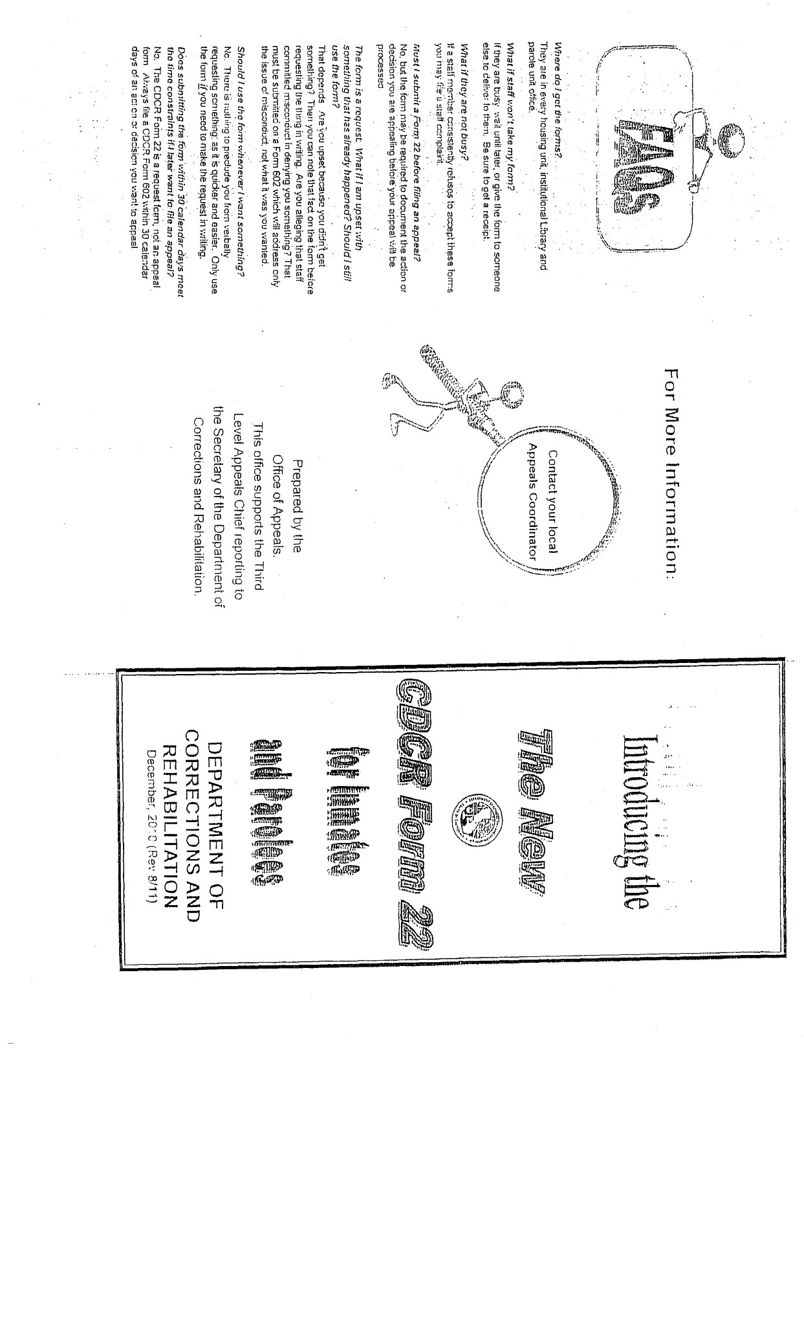

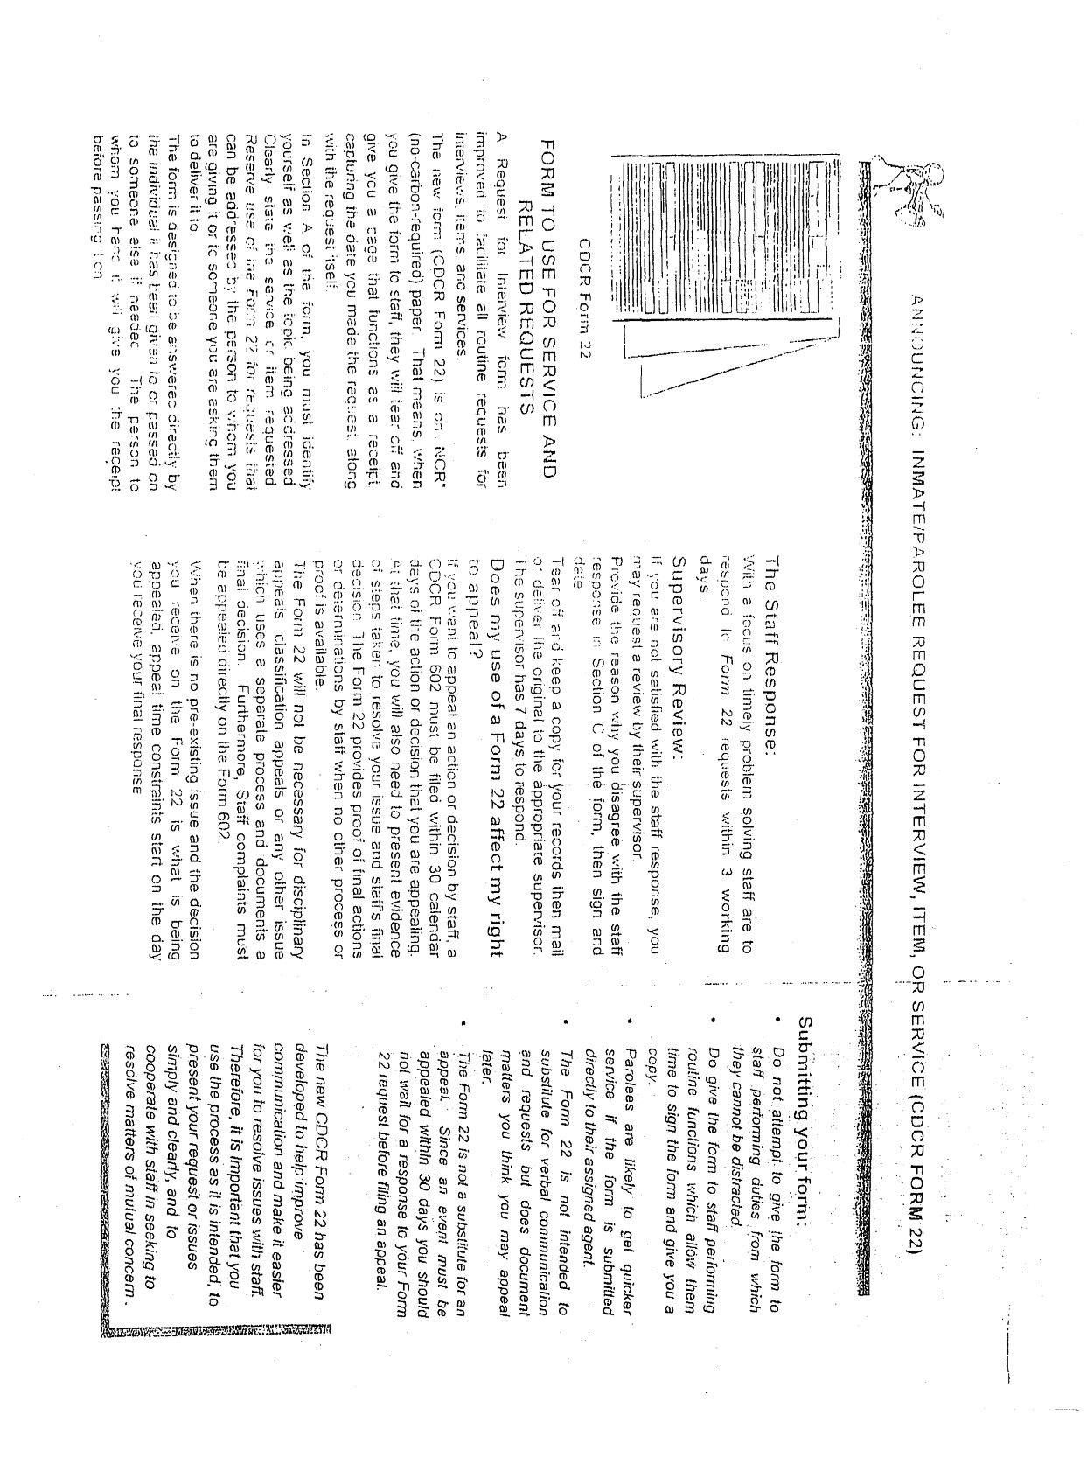
Form 22
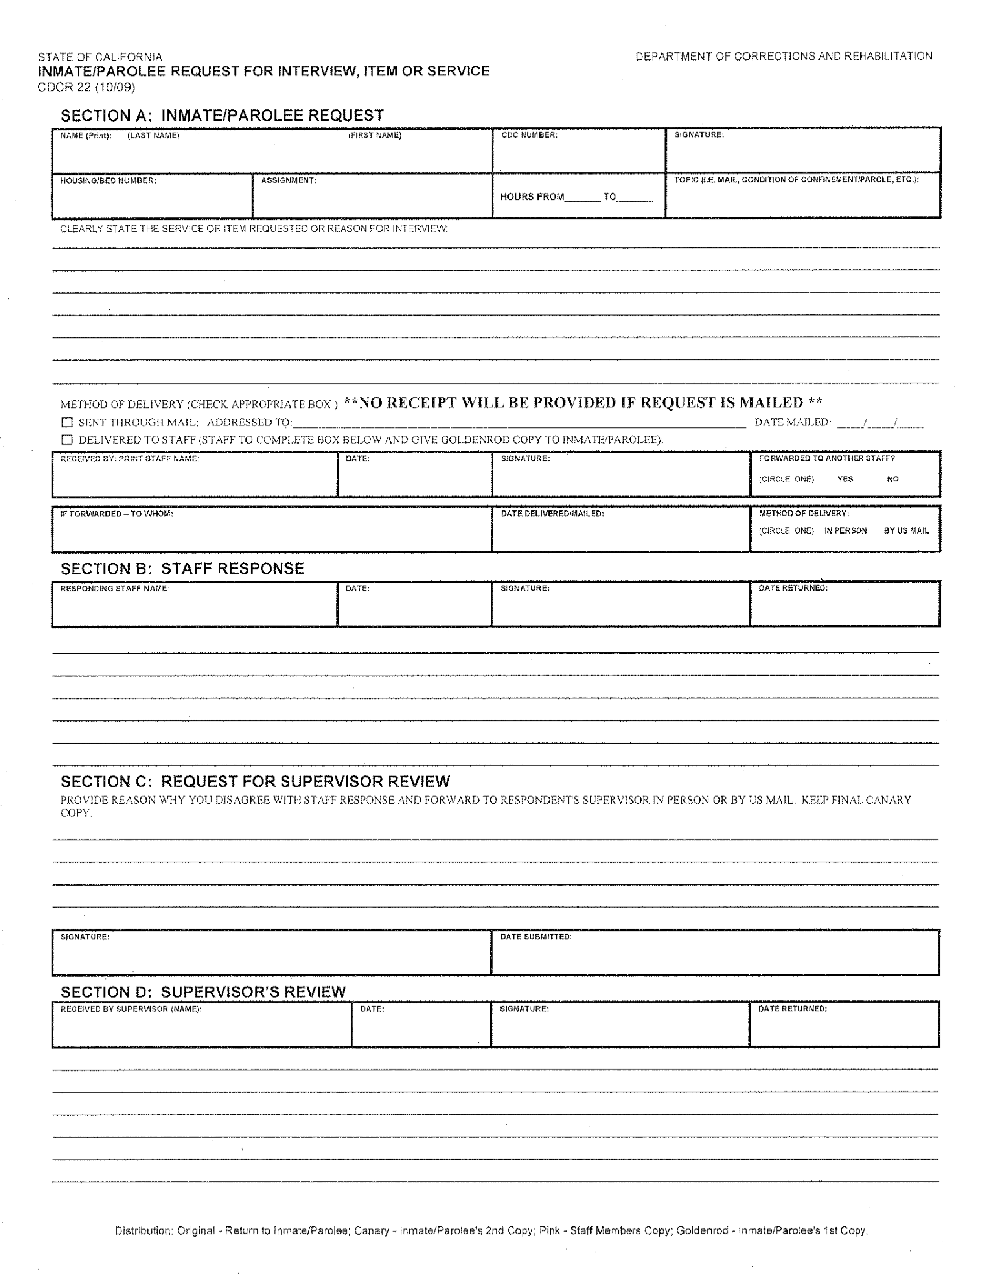

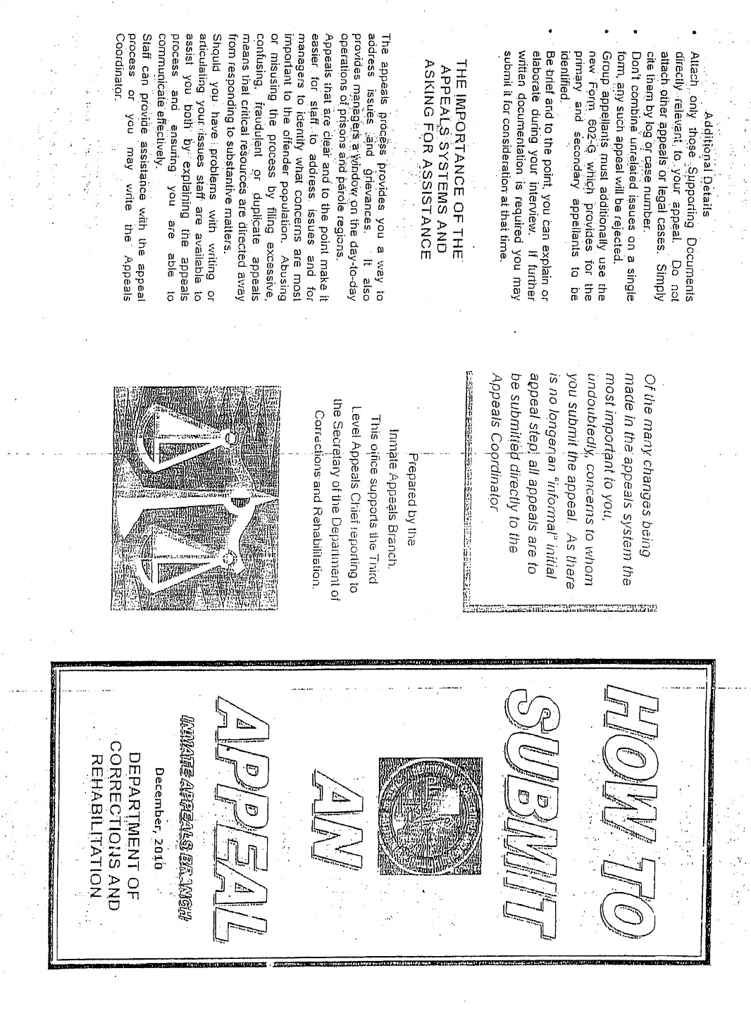
Form 602 informational pamphlet

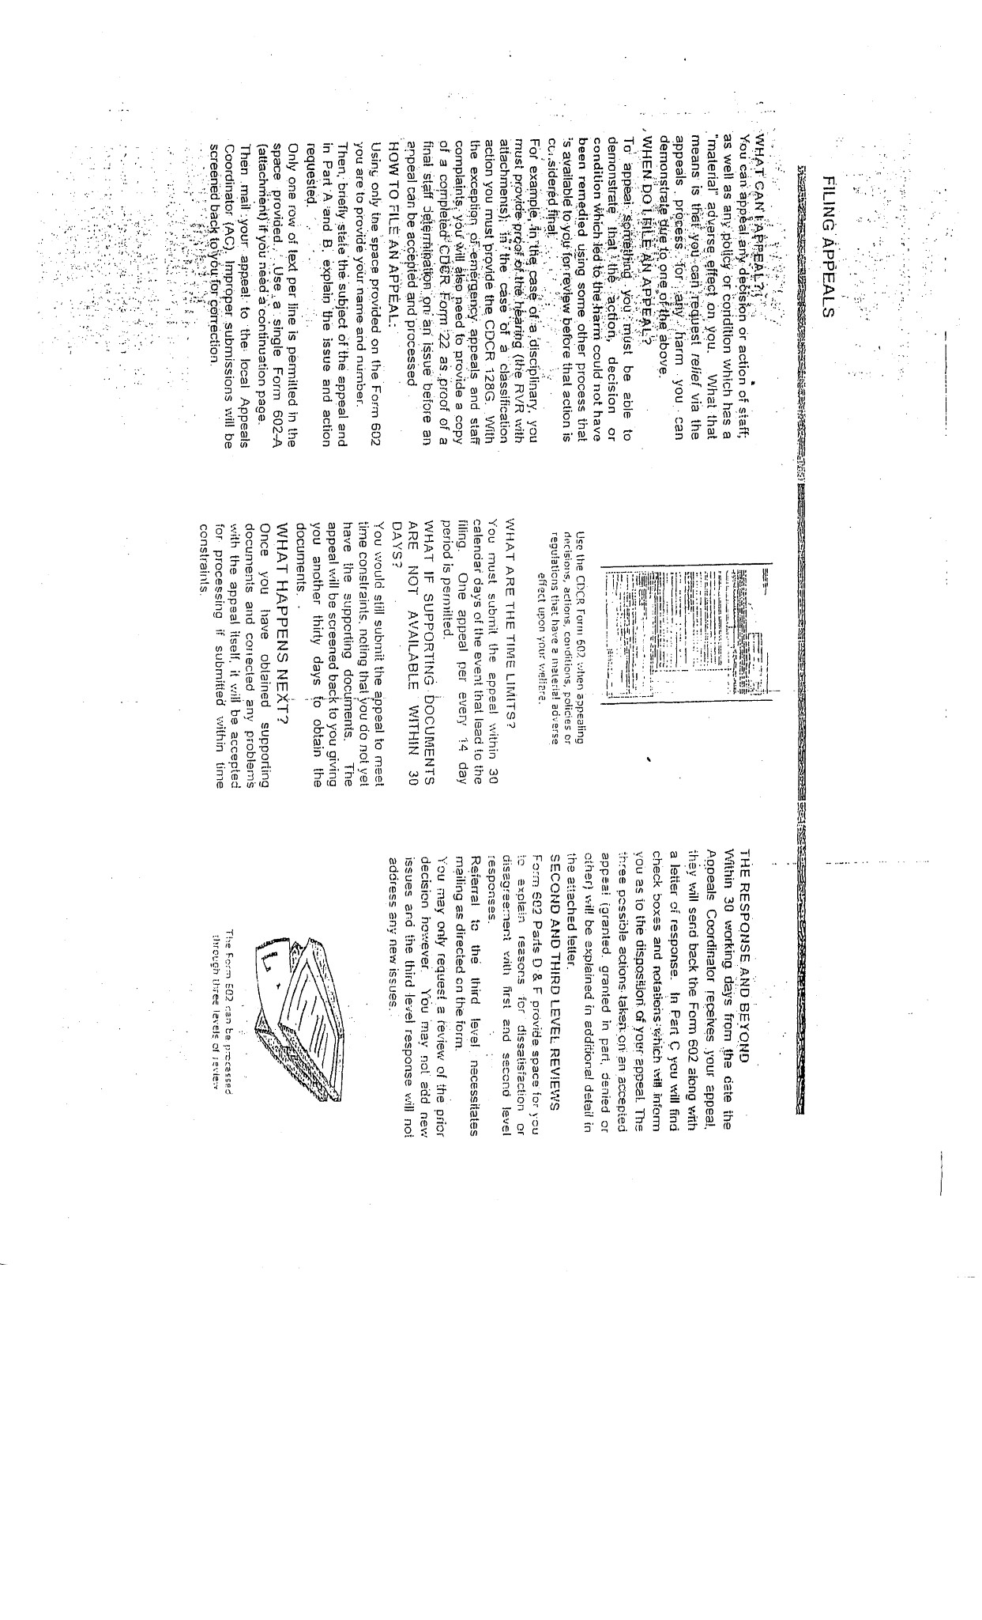
Definitions

For the purpose of Article 8, the following definitions shall apply:
- Appellant means an inmate or parolee who has submitted an appeal.
- General allegations means allegations that lack specificity or factual evidence to support them.
- Material adverse effect means a harm or injury that is measurable or demonstrable, or the reasonable likelihood of such harm or injury. In either case, the harm or injury must be due to any policy, decision, action, condition, or omission by the department or its staff.
- Modification order means an order by the institution, parole region, or third level Appeals Chief directing a previous decision to be modified.
- Remedy means a process or means to address an issue or correct a wrong.
- Reviewer means the individual with signature authority for the approval or disapproval of an appeal response at any level.
- Staff misconduct means staff behavior that violates or is contrary to law, regulation, policy, procedure, or an ethical or professional standard.
- Supporting documents means documents that are needed to substantiate allegations made in the appeal including, but not limited to, classification chronos, property inventory sheets, property receipts, disciplinary reports with supplements, incident reports, notifications of disallowed mail, trust account statements, memoranda or letters, medical records and written requests for interviews, items or services. Supporting documents do not include documents that simply restate the matter under appeal, argue its merits, or introduce new issues not identified in the present appeal form.

Appeal Time Limits
- Time limits for reviewing appeals shall commence upon the date of receipt of the appeal form by the appeals coordinator.
- An inmate or parolee must submit the appeal within 30 calendar days of:
- The occurrence of the event or decision being appealed, or;
- Upon first having knowledge of the action or decision being appealed, or;
- Upon receiving an unsatisfactory departmental response to an appeal filed.
(c) All appeals shall be responded to and returned to the inmate or parolee by staff within the following time limits, unless exempted pursuant to the provisions of subsections 3084.8(f) and (g):
- First level responses shall be completed within 30 working days from date of receipt by the appeals coordinator.
- Second level responses shall be completed within 30 working days from date of receipt by the appeals coordinator.
- Third level responses shall be completed within 60 working days from date of receipt by the third level Appeals Chief.
(d) Exception to the time limits provided in subsection 3084.8(c) is authorized only in the event of:
- Unavailability of the inmate or parolee, or staff, or witnesses.
- The complexity of the decision, action, or policy requiring additional research.
- Necessary involvement of other agencies or jurisdictions.
- State of emergency pursuant to subsection 3383(c) requiring the postponement of nonessential administrative decisions and actions, including normal time requirements for such decisions and actions.
- Except for the third level, if an exceptional delay prevents completion of the review within specified time limits, the appellant, within the time limits provided in subsection 3084.8(c), shall be provided an explanation of the reasons for the delay and the estimated completion date.
- An appeal accepted as an emergency appeal shall be processed within the time frames set forth in subsections 3084.9(a) (4) and (a)(5).
- An appeal of the involuntary psychiatric transfer of an inmate or parolee shall be made directly to the third level pursuant to subsection 3084.9(b), within 30 calendar days of receipt of the hearing decision on the need for involuntary transfer.

MODULE 5

Appeal preparation
  - Right to appeal
  - Supporting documents
  - Appeal system abuse

Right to Appeal.
The appeal process is intended to provide a remedy for inmates and parolees with identified grievances and to provide an administrative mechanism for review of departmental policies, decisions, actions, conditions, or omissions that have a material adverse effect on the welfare of inmates and parolees. All appeals shall be processed according to the provisions of Article 8, Appeals, unless exempted from its provisions pursuant to court order or superseded by law or other regulations.
(a) Any inmate or parolee under the department’s jurisdiction may appeal any policy, decision, action, condition, or omission by

3084.1
the department or its staff that the inmate or parolee can demonstrate as having a material adverse effect upon his or her health, safety, or welfare.
- Unless otherwise stated in these regulations, all appeals are subject to a third level of review, as described in section 3084.7, before administrative remedies are deemed exhausted. All lower level reviews are subject to modification at the third level of review. Administrative remedies shall not be considered exhausted relative to any new issue, information, or person later named by the appellant that was not included in the originally submitted CDCR Form 602 (Rev. 08/09), Inmate/Parolee Appeal, which is incorporated by reference, and addressed through all required levels of administrative review up to and including the third level. In addition, a cancellation or rejection decision does not exhaust administrative remedies.
- Department staff shall ensure that inmates and parolees, including those who have difficulties communicating, are provided equal access to the appeals process and the timely assistance necessary to participate throughout the appeal process.
- No reprisal shall be taken against an inmate or parolee for filing an appeal. This shall not prohibit appeal restrictions against an inmate or parolee abusing the appeal process as defined in section 3084.4, nor shall it prohibit the pursuit of disciplinary sanctions for violation of department rules.
- The department shall ensure that its departmental appeal forms for appeal of decisions, actions, or policies within its jurisdiction are readily available to all inmates and parolees.
- An inmate or parolee has the right to file one appeal every 14 calendar days unless the appeal is accepted as an emergency appeal. The 14 calendar day period shall commence on the day following the appellant’s last accepted appeal.
- An appellant shall adhere to appeal filing time constraints as defined in section 3084.8.

Supporting Documents.
- An inmate or parolee shall obtain and attach all supporting documents, as described in section 3084(h), necessary for the clarification and/or resolution of his or her appeal issue prior to submitting the appeal to the appeals coordinator.
- The inmate or parolee shall not delay submitting an appeal within time limits established in section 3084.8 if unable to obtain supporting documents, but shall submit the appeal with all available supporting documents and in Part B of their CDCR Form 602 (Rev. 08/09), Inmate/Parolee Appeal, provide an explanation why any remaining supporting documents are not available. Time limits for filing an appeal are not stayed by failure to obtain supporting documentation and commence as set forth in subsection 3084.8(b).
- Failure to attach all necessary supporting documents may result in the appeal being rejected as specified in subsection 3084.6(b)(7). The appeals coordinator shall inform the inmate or parolee that the appeal is rejected because necessary supporting documents are missing. The appellant shall be allowed an additional 30 calendar days to secure any missing supporting documents and resubmit the appeal.
- The appeals coordinator may grant additional time extensions beyond the initial 30 calendar day extension if the inmate or parolee submits a reasonable explanation of why the supporting documents still are not available.

Appeal System Abuse.
(a) The following are deemed misuse or abuse of the appeals process and may lead to appeal restriction as described in subsection 3084.4(g).
- The submittal of more than one appeal for initial review within a 14 calendar day period is considered excessive, unless the inmate or parolee is submitting an emergency appeal.
- The repeated filing of appeals that have been cancelled pursuant to subsection 3084.6(c).
- The appeal submission contains information the appellant knows to be false or consists of a deliberate attempt at distorting the facts.
- The appeal contains threatening, grossly derogatory, slanderous or obscene statements and/or organic contamination is included in or makes up any part of the appeal package.
- The description of the problem and/or requested action deliberately exceeds the space provided on the 602 forms or the appeal is intentionally filed contrary to instructions.
(b) When an inmate or parolee submits appeals as described above in subsections 3084.4(a)(1)–(a)(5):
- The first appeal received shall be screened for routine processing.
- All subsequent non-emergency appeals submitted by that individual shall be screened and the appeals coordinator shall begin documenting any abuse as evidenced by the screening results.
- If an inmate or parolee persists in submitting excessive, demonstrably false, noncompliant or abusive appeals, as described in subsection 3084.4(a), he or she shall receive a warning letter from the appeals coordinator that will document the history and nature of appeal system abuse.
- If the abuse of process continues after the issuance of a warning letter, the appeals coordinator shall meet with the inmate or parolee in a timely manner before imposition of any restriction to provide instruction for the appropriate use of the appeals process and to rule out any unintended basis for non-compliance. If a faceto-face meeting is not possible, an agent acting on behalf of the appeals coordinator shall conduct the meeting.
- Excessive, demonstrably false, noncompliant or abusive appeals, as described in subsection 3084.4(a), submitted by an inmate or parolee after the issuance of a warning letter, pursuant to subsection 3084.4(c) above, shall be screened by the appeals coordinator to ensure they do not contain qualifying emergency issues.
- If the appeal contains emergency issues, as described in subsection 3084.9(a)(1), it shall be processed as an emergency appeal.
- If no such issue is determined to be present, the appeal shall be retained by the appeals coordinator pending placement of the appellant on appeal restriction by the third level Appeals Chief. The appellant shall be informed in writing why the appeal constitutes abuse of the appeal process and informed that appeal processing has been suspended pending determination of appeal restriction status.
- If the appeal abuse continues after the issuance of a warning letter and a face-to-face meeting, the request for placement on restriction shall be referred to the third level Appeals Chief for approval.
- Upon confirmation of continued abuse and verification that a face-to-face interview and warning letter have occurred, the third level Appeals Chief shall have the discretion to authorize preparation of a notice by the Appeals Coordinator restricting the inmate or parolee to one non-emergency appeal every 30 calendar days for a period of one year. Any subsequent violation of the appeal restriction shall result in an extension of the restriction for an additional one-year period upon approval by the third level Appeals Chief.
- If the third level Appeals Chief makes a decision not to place the inmate or parolee on appeal restriction, any appeal submitted by the inmate or parolee and retained pursuant to subsection 3084.4(e) (2) shall be returned to the inmate or parolee who may then resubmit a returned appeal if he or she desires to do so. Resubmitted appeals are not exempt from the standard submittal requirements set forth in this Article, except that the appellant’s original submittal date of the appeal may serve to satisfy filing time requirements.

MODULE 6

appeal process
  - Screening and managing appeals
  - Level of appeal review and disposition
  - Rejection, cancellation, withdrawal
  - Exceptions to the process

Screening and Managing Appeals.
- Each institution head and parole region administrator shall designate an appeals coordinator at a staff position level no less than a Correctional Counselor II or Parole Agent II.
- The appeals coordinator or a delegated staff member under the direct oversight of the coordinator shall screen all appeals prior to acceptance and assignment for review.
- When an appeal indicates the inmate or parolee has difficulty describing the problem in writing or has a primary language other than English, the appeals coordinator shall ensure that the inmate or parolee receives assistance in completing and/or clarifying the appeal.
- When an appeal is received as an emergency appeal that does not meet the criteria for an emergency appeal as defined in subsection 3084.9(a), the appellant shall be notified that the appeal does not meet the criteria for processing as an emergency appeal and has been either accepted for regular processing or is rejected for the specific reason(s) cited.
- When an appeal is not accepted, the inmate or parolee shall be notified of the specific reason(s) for the rejection or cancellation of the appeal and of the correction(s) needed for the rejected appeal to be accepted.
- When an appeal is received that describes staff behavior or activity in violation of a law, regulation, policy, or procedure or appears contrary to an ethical or professional standard that could be considered misconduct as defined in subsection 3084(g), whether such misconduct is specifically alleged or not, the matter shall be referred pursuant to subsection 3084.9(i)(1) and (i)(3), to determine whether it shall be:
- Processed as a routine appeal but not as a staff complaint.
- Processed as a staff complaint appeal inquiry.
- Referred to Internal Affairs for an investigation/inquiry.
(5) If an appeal classified as a staff complaint includes other non-related issue(s), the provisions of 3084.9(i)(2) shall apply.

Levels of Appeal Review and Disposition.
(a) All appeals shall be initially submitted and screened at the first level unless the first level is exempted. The appeals coordinator may bypass the first level for appeal of:
- A policy, procedure or regulation implemented by the department.
- A policy or procedure implemented by the institution head.
- An issue that cannot be resolved at the division head level such as Associate Warden, Associate Regional Parole Administrator, CALPIA manager or equivalent.
- Serious disciplinary infractions.
(b) The second level is for review of appeals denied or not otherwise resolved to the appellant’s satisfaction at the first level, or for which the first level is otherwise waived by these regulations. The second level shall be completed prior to the appellant filing at the third level as described in subsection 3084.7(c).
- A second level of review shall constitute the department’s final action on appeals of disciplinary actions classified as “administrative” as described in section 3314, or of minor disciplinary infractions documented on the CDC Form 128-A (rev. 4-74), Custodial Counseling Chrono, pursuant to section 3312(a)(2), and shall exhaust administrative remedy on these matters.
- Movies/videos that have been given a rating of other than “G”, “PG”, or “PG-13” by the Motion Picture Association of America are not approved for either general inmate viewing pursuant to section 3220.4 or for viewing within the classroom, and will not be accepted for appeal at any level. The first level shall be waived for appeals related to the selection or exclusion of a “G”, “PG”, or “PG-13” rated or non-rated movie/video for viewing and the second level response shall constitute the department’s final response on appeals of this nature.
- Civil addict/releasee exclusion appeals. Civil addicts or releasees may appeal a staff recommendation for exclusion from the civil addict program, unless the recommendation is based upon a commitment to prison, deportation, or releasee-at-large status. A second level review shall constitute the department’s final response on appeals of this type.
(c) The third level is for review of appeals not resolved at the second level, or:
- When the inmate or parolee appeals alleged third level staff misconduct or appeals a third level cancellation decision or action.
- In the event of involuntary psychiatric transfers as provided in subsection 3084.9(b).
(d) Level of staff member conducting review.
(1) Appeal responses shall not be reviewed and approved by a staff person who:
- Participated in the event or decision being appealed. This does not preclude the involvement of staff who may have participated in the event or decision being appealed, so long as their involvement with the appeal response is necessary in order to determine the facts or to provide administrative remedy, and the staff person is not the reviewing authority and/or their involvement in the process will not compromise the integrity or outcome of the process.
- Is of a lower administrative rank than any participating staff. This does not preclude the use of staff, at a lower level than the staff whose actions or decisions are being appealed, to research the appeal issue.
- Participated in the review of a lower level appeal refiled at a higher level.
- Second level review shall be conducted by the hiring authority or designee at a level no lower than Chief Deputy Warden, Deputy Regional Parole Administrator, or the equivalent.
- The third level review constitutes the decision of the Secretary of the California Department of Corrections and Rehabilitation on an appeal, and shall be conducted by a designated representative under the supervision of the third level Appeals Chief or equivalent. The third level of review exhausts administrative remedies; however, this does not preclude amending a finding previously made at the third level.
(e) At least one face-to-face interview shall be conducted with the appellant at the first level of review, or the second level if the first level of review is bypassed, unless:
(1) The appellant waives the interview by initialing the appropriate box on the CDCR Form 602 (Rev. 08/09), Inmate/Parolee

3084.7
Appeal. An appellant’s waiver of the interview shall not preclude staff from conducting an interview in the event of staff determination that an interview is necessary.
- The reviewer has decided to grant the appeal in its entirety.
- The appeal is a request for a Computation Review Hearing, in which case the initial interview shall occur at the second level of review.
- The appellant is not present at the institution or parole region where the appeal was filed.
- In such case, a telephone interview with the appellant shall meet the requirement of a personal interview. If the appeal concerns a disciplinary action, the telephone interview may be waived if the appeals coordinator determines an interview would not provide additional facts.
- The response must note that the interview was conducted by telephone, explain the extraordinary circumstances that required it, and state why a face-to-face interview was not possible under the circumstances.
- If the appellant is not available for a telephone interview, the reviewer may request that a suitable employee in the jurisdiction where the appellant is located complete the interview and provide a report.
- An interview may be conducted at any subsequent level of review when staff determine that the issue under appeal requires further clarification.
- When a group or multiple appeal is received, one or more of the participating inmates/parolees shall be interviewed to clarify the issue(s).
- At the first and second level of review, the original appeal, within the time limits provided in section 3084.8, shall be returned to the appellant with a written response to the appeal issue providing the reason(s) for each decision. Each response shall accurately describe the matter under appeal and fully address the relief requested. If the decision is a partial grant, the response shall clarify for each requested action whether it is granted, granted in part, or denied, and shall also state the action taken.
- Modification orders issued by the institution, parole region, or by the third level of review shall be completed within 60 calendar days of the appeal decision which determined the need for a modification order. Reasonable documented proof of completion of the modification order shall accompany the completed order, or a statement shall be added by the responder clarifying the action taken and why documentation is not available.
- If it is not possible to comply with the modification order within 60 calendar days, staff responsible for complying with the modification order shall advise the local appeals coordinator every 30 calendar days of the reason for the delay and provide a projected date of completion. If the modification order was imposed by the third level of review, the local appeals coordinator shall notify the third level Appeals Chief every 30 calendar days of the reason for the delay and provide a projected date of completion.
- When it is clear that the modification order cannot be completed in the allotted time, the appeals coordinator shall advise the appellant of the reason for the delay and the anticipated date of completion. This process shall occur every 30 calendar days until the modification order is completed. All time constraints for an appellant to submit an appeal to the next level are considered postponed up to 120 days until the completion of a previous level modification order. Thereafter, the appellant must submit his/her appeal to the next level within 30 calendar days of receiving the modification order response.
- If the modification order is not completed after 120 calendar days of the issuance, the appellant may submit the appeal to the next level for administrative review within 30 calendar days.

3084.8
- If the appellant transfers prior to the completion of the modification order, the originally assigned institution or parole region shall retain responsibility for completion of the modification order as specified in subsection 3084.7(i), including cases where the receiving institution or parole region provides the actual relief.
- In cases where a modification order is issued on an emergency appeal, the order shall specify the timeframe for the completion of the action granted. The appeals coordinator, if granted at the second level of review, and the third level Appeals Chief or designee, if granted at the third level of review, shall notify the hiring authority by electronic transmission of the emergency timeframe for completion of the granted action.

Rejection, Cancellation, and Withdrawal Criteria.
(a) Appeals may be rejected pursuant to subsection 3084.6(b), or cancelled pursuant to subsection 3084.6(c), as determined by the appeals coordinator.
- Unless the appeal is cancelled, the appeals coordinator shall provide clear and sufficient instructions regarding further actions the inmate or parolee must take to qualify the appeal for processing.
- An appeal that is rejected pursuant to subsection 3084.6(b) may later be accepted if the reason noted for the rejection is corrected and the appeal is returned by the inmate or parolee to the appeals coordinator within 30 calendar days of rejection.
- At the discretion of the appeals coordinator or third level Appeals Chief, a cancelled appeal may later be accepted if a determination is made that cancellation was made in error or new information is received which makes the appeal eligible for further review.
- Under exceptional circumstances any appeal may be accepted if the appeals coordinator or third level Appeals Chief conclude that the appeal should be subject to further review. Such a conclusion shall be reached on the basis of compelling evidence or receipt of new information such as documentation from health care staff that the inmate or parolee was medically or mentally incapacitated and unable to file.
- Erroneous acceptance of an appeal at a lower level does not preclude the next level of review from taking appropriate action, including rejection or cancellation of the appeal.
(b) An appeal may be rejected for any of the following reasons, which include, but are not limited to:
- The appeal concerns an anticipated action or decision.
- The appellant has failed to demonstrate a material adverse effect on his or her welfare as defined in subsection 3084(c).
- The inmate or parolee has exceeded the allowable number of appeals filed in a 14 calendar day period pursuant to the provisions of subsection 3084.1(f).
- The appeal contains threatening, obscene, demeaning, or abusive language.
- The inmate or parolee has attached more than one CDCR Form 602-A (08/09), Inmate/Parolee Appeal Form Attachment.
- The appeal makes a general allegation, but fails to state facts or specify an act or decision consistent with the allegation.
- The appeal is missing necessary supporting documents as established in section 3084.3.
- The appeal involves multiple issues that do not derive from a single event, or are not directly related and cannot be reasonably addressed in a single response due to this fact.
- The appeal issue is obscured by pointless verbiage or voluminous unrelated documentation such that the reviewer cannot be reasonably expected to identify the issue under appeal. In such case, the appeal shall be rejected unless the appellant is identified as requiring assistance in filing the appeal as described in subsection 3084.1(c).
- The inmate or parolee has not submitted his/her appeal printed legibly in ink or typed on the lines provided on the appeal forms in no smaller than a 12-point font or failed to submit an original.
- The appeal documentation is defaced or contaminated with physical/organic objects or samples as described in subsection 3084.2(b)(4). Appeals submitted with hazardous or toxic material that present a threat to the safety and security of staff, inmates, or the institution may subject the appellant to disciplinary action and/or criminal charges commensurate with the specific act.

3084.7
- The appellant has attached dividers or tabs to the appeal forms and/or supporting documents.
- The appeal is incomplete; for example, the inmate or parolee has not provided a signature and/or date on the appeal forms in the designated signature/date blocks provided.
- The inmate or parolee has not submitted his/her appeal on the departmentally approved appeal forms.
- The inmate or parolee has submitted the appeal for processing at an inappropriate level bypassing required lower level(s) of review, e.g., submitting an appeal at the third level prior to lower level review.
- The appeal issue or complaint emphasis has been changed at some point in the process to the extent that the issue is entirely new, and the required lower levels of review and assessment have thereby been circumvented.
(c) An appeal may be cancelled for any of the following reasons, which include, but are not limited to:
- The action or decision being appealed is not within the jurisdiction of the department.
- The appeal duplicates an inmate or parolee’s previous appeal upon which a decision has been rendered or is pending.
- The inmate or parolee continues to submit a rejected appeal while disregarding appeal staff’s previous instructions to correct the appeal including failure to submit necessary supporting documents, unless the inmate or parolee provides in Part B of the CDCR Form 602 (Rev. 08/09), Inmate/Parolee Appeal, a reasonable explanation of why the correction was not made or documents are not available.
- Time limits for submitting the appeal are exceeded even though the inmate or parolee had the opportunity to submit within the prescribed time constraints. In determining whether the time limit has been exceeded, the appeals coordinator shall consider whether the issue being appealed occurred on a specific date or is ongoing. If the issue is ongoing, which may include but is not limited to, continuing lockdowns, retention in segregated housing, or an ongoing program closure, the inmate or parolee may appeal any time during the duration of the event; however, the inmate or parolee is precluded from filing another appeal on the same issue unless a change in circumstances creates a new issue.
- The appeal is submitted on behalf of another person.
- The issue is subject to a department director level review independent of the appeal process such as a Departmental Review Board decision, which is not appealable and concludes the appellant’s departmental administrative remedy pursuant to the provisions of section 3376.1.
- The appellant is deceased before the time limits for responding to an appeal have expired and the appeal is not a group appeal.
- The appellant refuses to be interviewed or to cooperate with the reviewer.
- The appellant’s refusal to be interviewed or to cooperate with the reviewer shall be clearly articulated in the cancellation notice.
- If the appellant provides sufficient evidence to establish that the interviewer has a bias regarding the issue under appeal, the appeals coordinator shall assign another interviewer.
- The appeal is presented on behalf of a private citizen.
- Failure to correct and return a rejected appeal within 30 calendar days of the rejection.
- The issue under appeal has been resolved at a previous level.
- Group appeals shall not be cancelled at the request of the submitting individual unless all of the inmate signatories are released, transferred, or agree to withdraw the appeal.
- Once cancelled, an appeal shall not be accepted except pursuant to subsection 3084.6(a)(3); however, the application of the rules provided in subsection 3084.6(c) to the cancelled appeal may be separately appealed. If an appeal is cancelled at the third level of review, any appeal of the third level cancellation decision shall be made directly to the third level Appeals Chief.
- An appeal may be withdrawn by the appellant by requesting to have the processing stopped at any point up to receiving a signed response. The request for the withdrawal shall identify the reason for the withdrawal in section H of the CDCR Form 602, Inmate/Parolee Appeal and shall be signed and dated by the appellant. If there is an agreed upon relief noted in writing at the time of a withdrawal and the relief is not provided when and as promised, then the failure to provide the agreed upon relief may be appealed within 30 calendar days of the failure to grant the promised relief. The withdrawal of an appeal does not preclude further administrative action by the department regarding the issue under appeal. A withdrawn staff complaint shall be returned to the hiring authority to review for possible further administrative action.

Exceptions to the Regular Appeal Process.
(a) Emergency appeals. Emergency appeals should not be used by inmates or parolees as a substitute for verbally or otherwise informing staff of an emergency situation requiring immediate response.
(1) When circumstances are such that the regular appeal time limits would subject the inmate or parolee to a substantial risk of personal injury or cause other serious and irreparable harm, the appeal shall be processed as an emergency appeal. Emergency circumstances include, but are not limited to:
- Threat of death or injury due to enemies or other placement concerns.
- Serious and imminent threat to health or safety.
- An emergency appeal shall be submitted directly to the appeals coordinator and shall include a clear description of the circumstances warranting emergency processing. A request for emergency processing of an appeal that clearly does not meet the criteria for emergency processing or is made for the purpose of circumventing normal procedures or obtaining an expedited response may be considered misuse or abuse of the appeals process.
- If the appeals coordinator determines emergency processing is unwarranted, the inmate or parolee shall be notified and the appeal shall be processed pursuant to subsection 3084.5(b)(2).
- If emergency processing is warranted, the first level shall be waived and the second level review shall be completed within five working days.
- Involuntary psychiatric transfers. An inmate or parolee may appeal the written decision of an involuntary psychiatric transfer, pursuant to subsection 3379(d), directly to the third level. A copy of the hearing decision shall be attached to the CDCR Form 602 (Rev. 08/09), Inmate/Parolee Appeal, but the absence of such documentation shall not be cause for rejection of the appeal.
- Joint Venture Program (JVP) employer related grievances.
- Any current or former Joint Venture inmate-employee who believes he/she has a grievance regarding a wage and hour or retaliation claim against a JVP employer shall submit the written grievance to the JVP Chief.
- The JVP Chief shall attempt to resolve all complaints.
- Time frames for filing grievances will be governed by the Division of Labor Standards Enforcement’s (DLSE) statutes of limitations, including but not limited to, Labor Code section 98.7 and Code of Civil Procedure sections 337, 338, and 339, for the appropriate type of complaint.
- If the inmate is dissatisfied with the JVP Chief’s decision, the inmate may file a complaint with the Labor Commissioner.
(d) Parole period and term computation appeals. Parole period and term computation appeals shall be reviewed at the first level by the department’s records staff. The inmate or parolee must state in detail the alleged error or reason for disputing the calculation of his or her release date.

3084.9
- Records staff shall research the relevant case factors and document the findings. If the appeal is denied, the denial shall be delivered by records staff or by the appropriate caseworker to the appellant who shall sign and date a CDC Form 1031 (8-88), Acknowledgement of Receipt.
- The inmate or parolee may request a Computation Review Hearing that constitutes the second level review. The inmate or parolee shall be notified at least 24 hours prior to the hearing via the CDC Form 1032 (12/86), Notice of Time, Date, and Place of Computation Review Hearing, but may sign a voluntary waiver of such notice.
- The inmate or parolee shall be provided a copy of the CDC Form 1033 (8-88), Computation Review Hearing Decision, at the conclusion of the hearing.
(e) California Prison Industry Authority (CALPIA) health and safety complaints.
- A health and safety complaint should not be used by inmates as a substitute for verbally or otherwise informing staff of an urgent health or safety situation requiring immediate response.
- Pursuant to Labor Code and Industrial Relations regulations, an inmate who believes a health or safety hazard exists in a CALPIA operation shall deposit a written complaint in a readily accessible complaint box or give the complaint to any CALPIA staff member who shall submit it to the CALPIA health and safety committee for review and response. The committee shall undertake all authorized levels of review and referral.
(f) Property appeals. All property loss or damage arising from the same event or action for a single appellant shall be included in one appeal.
- An inmate or parolee who is appealing missing/damaged property that he or she believes occurred as a result of an error made by the receiving entity or by the transportation unit during the transfer of his/her property shall submit the appeal to the appeals coordinator of the receiving institution/region.
- An inmate or parolee who is appealing missing/damaged property that he or she alleges occurred as a result of an error made by the sending entity during the transfer from one institution/region to another institution/region, shall submit the appeal to the appeals coordinator of the receiving institution/region who will forward it to the sending institution/region for processing.
- The appeals coordinator shall process the appeal for a first level response.
- An attempt shall be made by staff to assess the damaged property and/or conduct a thorough search to locate the missing property.
- An attempt shall be made by staff to research the appellant’s claim utilizing departmental inmate property records.
- If an administrative decision is made that the department is responsible for loss or damage to the appellant’s property pursuant to section 3193, an attempt by staff to use donated property to substitute for or replace lost property at no cost to the state, or any effort to repair damaged property at institution expense, will be made prior to awarding monetary compensation for the loss.
- An appellant’s refusal to accept repair, replacement, or substitution of like items and value shall be cause to deny the appeal. When denying an appeal on this basis, the reviewer must state why the replacement offered to the appellant is considered an equivalent item and value.
- The provisions of subsection 3193(b) shall apply when monetary compensation is determined to be the appropriate remedy.
- Before payment of any granted claim, the inmate or parolee shall discharge the state from further liability for the claim if required pursuant to Government Code section 965.

3084.9
- The document denying a property claim appeal shall inform the appellant of the right to submit a claim directly with the Victim Compensation and Government Claims Board and shall provide the mailing address for such filing.
- An inmate or parolee who intends to submit a claim with the Victim Compensation and Government Claims Board shall adhere to the rules and timeframes governing those claims, which may be more restrictive than those of the CDCR appeals process.
(g) Disciplinary Appeals.
- A disciplinary action cannot be appealed until the hearing process is completed, including any re-hearing.
- Inmates who wish to exhaust their administrative remedies for “serious” disciplinary issues pursuant to section 3315 must appeal through the third level of review.
(h) Transfer Appeals. A decision for transfer to another institution may be appealed by the affected inmate after the transfer endorsement by the classification staff representative.
- Filing of an appeal of a transfer decision shall not normally be cause to stay or delay a transfer except in extraordinary circumstances and at the discretion of the Warden or designee.
- Regular transfer appeals:
- The first level of appeal shall be waived.
- If the appeal is granted at second level, the appellant’s case shall be presented to a second classification staff representative for reconsideration.
- If the second classification staff representative disagrees with institution’s recommendation, the institution head may submit the case to the departmental review board for final decision.
- If the appeal is denied at second level or the institution head does not refer the case to the departmental review board, the appellant may appeal at the third level.
(3) Reception center transfer appeals:
- First level review shall be conducted by the reception center’s correctional administrator.
- If the appeal is granted, the appellant may be retained at the reception center until the case is presented to a second classification staff representative only if the proposed transfer poses a threat to the health or safety of the appellant.
- If the second classification staff representative disagrees with the first level appeal decision, the appellant may resubmit the appeal for second level review.
- Second level review shall be conducted by the institution head, who may retain the appellant at the reception center as a second level review action and refer the appeal to the departmental review board for resolution. The board’s decision shall constitute final review.
(i) Staff complaints. A staff complaint filed by an inmate or parolee shall be processed as an appeal pursuant to this Article, not as a citizen’s complaint. However, any appeal alleging misconduct by a departmental peace officer as defined in subsection 3291(b) shall be accompanied by the subsection 3391(d) Rights and Responsibility Statement.
- An inmate or parolee alleging staff misconduct by a departmental employee shall forward the appeal to the appeals coordinator. Only after the appeal has been reviewed and categorized as a staff complaint by the hiring authority or designee at a level not below Chief Deputy Warden, Deputy Regional Parole Administrator, or equivalent level shall it be processed as a staff complaint. If the hiring authority makes a determination that the complaint shall not be accepted as a staff complaint, it shall be processed as a routine appeal pursuant to subsection 3084.5(b)(4)(A).
- When an appeal is accepted alleging staff misconduct that also includes any other issue(s), the appeals coordinator at the time the appeal is accepted as a staff complaint shall notify the inmate or parolee that any other appeal issue(s) may only be appealed separately and therefore resubmission of those issues is required if the intention is to seek resolution of such matters. Upon receiving such a notice, the inmate or parolee has 30 calendar days to submit separate appeal(s) regarding the other issue(s).
- All appeals alleging staff misconduct will be presented by the appeals coordinator to the hiring authority or designee within five working days. The hiring authority will review the complaint and determine if:
- The allegation warrants a request for an Internal Affairs investigation as the alleged conduct would likely lead to adverse personnel action. The case will be referred for an Internal Affairs investigation as instructed by the hiring authority.
- The allegation does not warrant a request for an Internal Affairs investigation in which case a confidential inquiry shall be completed by the reviewer. An inquiry shall be conducted whenever the appeal is designated as a staff complaint but is not referred to the Office of Internal Affairs (OIA) or when the matter is declined by the OIA.
- A confidential report shall summarize the review and include a determination of the findings concerning the allegation. This document shall not be provided to the appellant. It shall be kept in the appeal file in the Appeals Office and no other copies shall be kept or maintained except as herein described or as needed for Third Level review or litigation. This document is strictly confidential to all inmates and any staff except those involved in the inquiry process or litigation involving the department.
- The accused staff may review the confidential report in the appeals office upon approval of the litigation coordinator, but if any information relating to other staff is contained in the confidential document, a copy shall be made and that information redacted prior to the review. Neither the original nor the copy shall leave the appeals office except as required for litigation and any redacted copy shall be placed with the original after review.
- The assigned reviewer will interview the appellant and as many witnesses as necessary to reach a determination concerning the allegation. The subject(s) of the staff complaint may be interviewed by a person trained to conduct administrative interviews and will be given notice of the interview at least 24 hours prior to the interview. If the subject chooses to waive the 24-hour requirement, he/she must indicate this at the time they are given notice. If waived, the subject may be interviewed immediately.
- A confidential inquiry shall review the information available to determine whether policy was violated.
(4) The institution’s appeal response to a staff complaint shall inform the appellant of either:
- The referral for investigation and the status of the investigation. Additionally, the appellant shall be notified of the outcome at the conclusion of the investigation.
- The decision to conduct a confidential inquiry and whether the findings determined that the staff in question did or did not violate departmental policy with regard to each of the specific allegation(s) made.
- A staff complaint alleging excessive or inappropriate use of force shall be addressed pursuant to the procedures described in sections 3268 through 3268.2.
- An appeal alleging staff misconduct by an appeals coordinator shall be reviewed by the hiring authority for determination of processing.

Module 7

- Solano sample packet
  - The appellant
  - Notoriety of case
  - Form 22
  - 602/ 602-A/ 602-G
  - Appeals Coordinator responses
  - Appellant letter to warden
  - Third level response
  - Supporting documents

  - The appellant

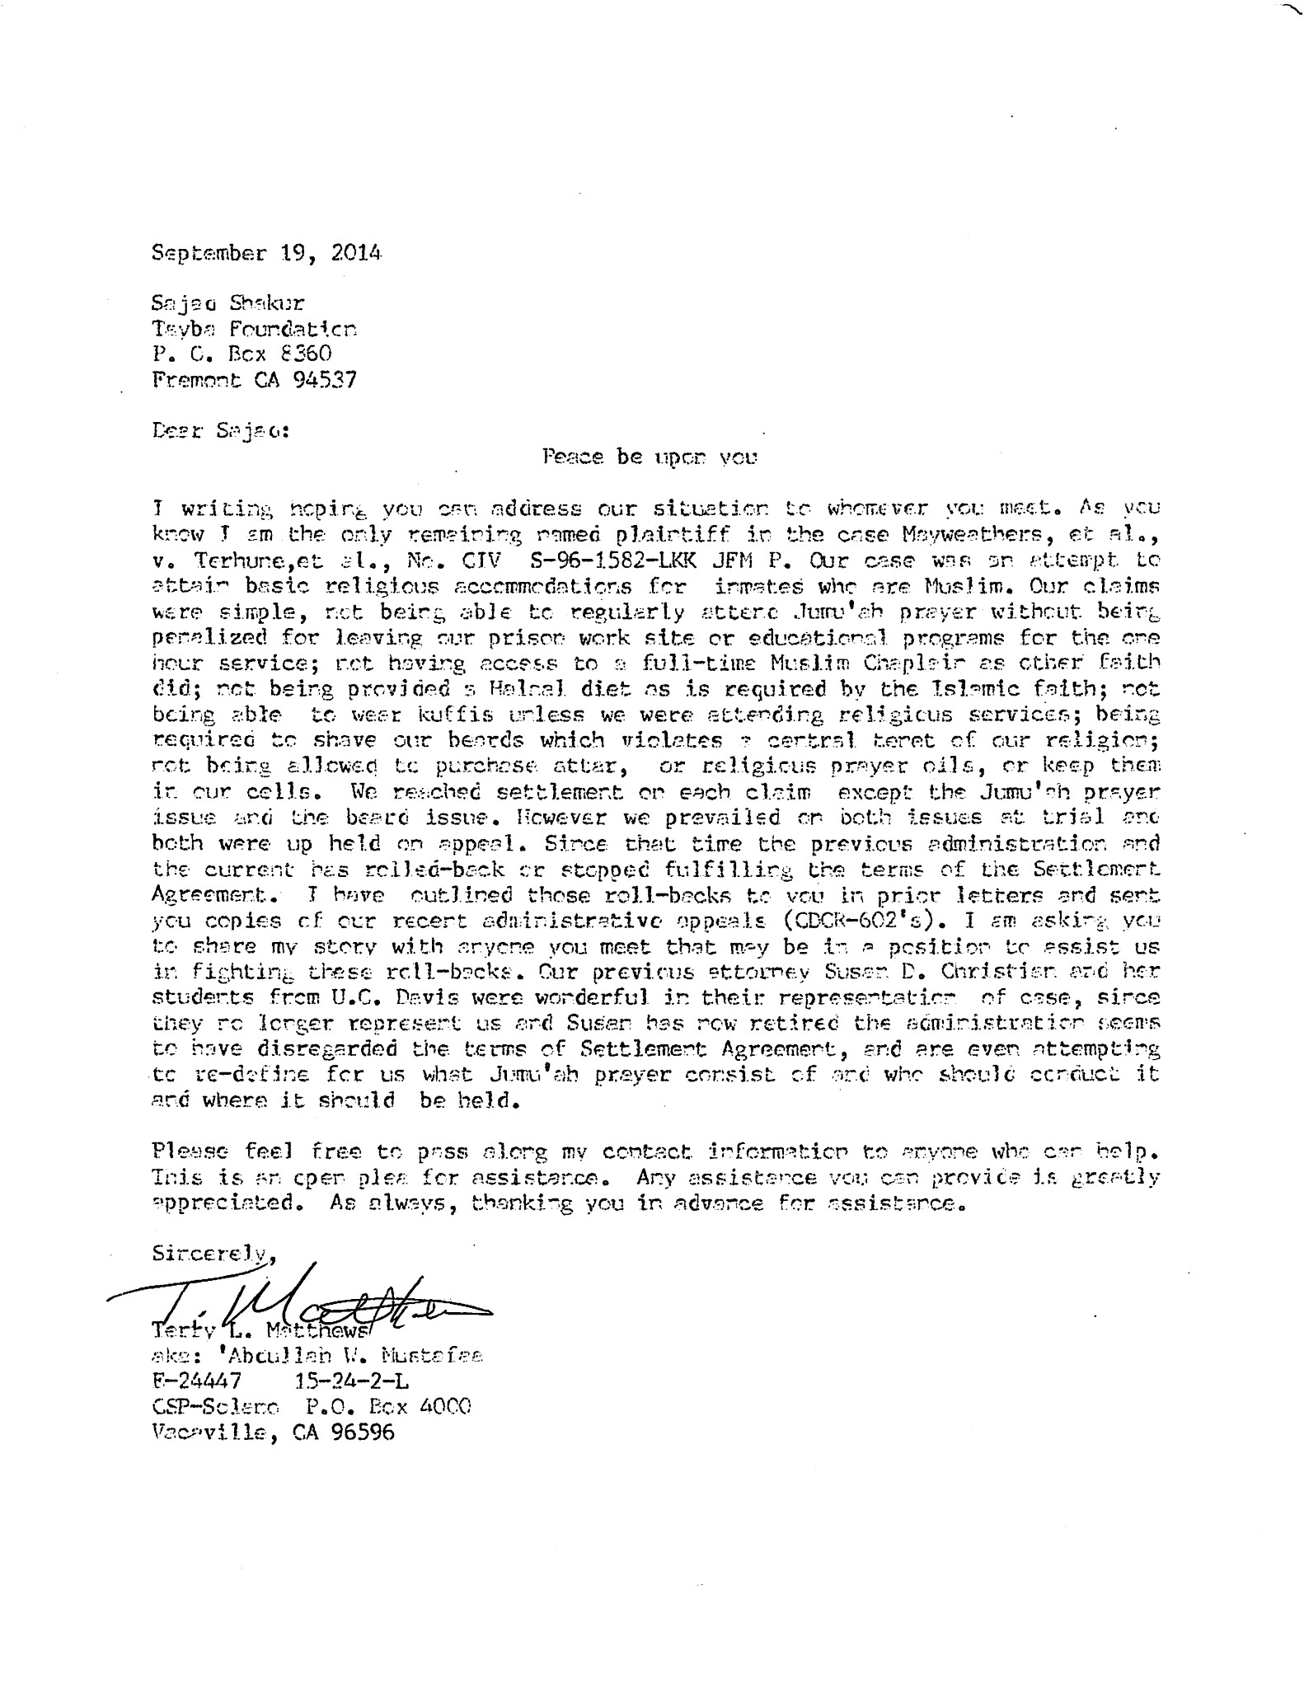

Notoriety of case

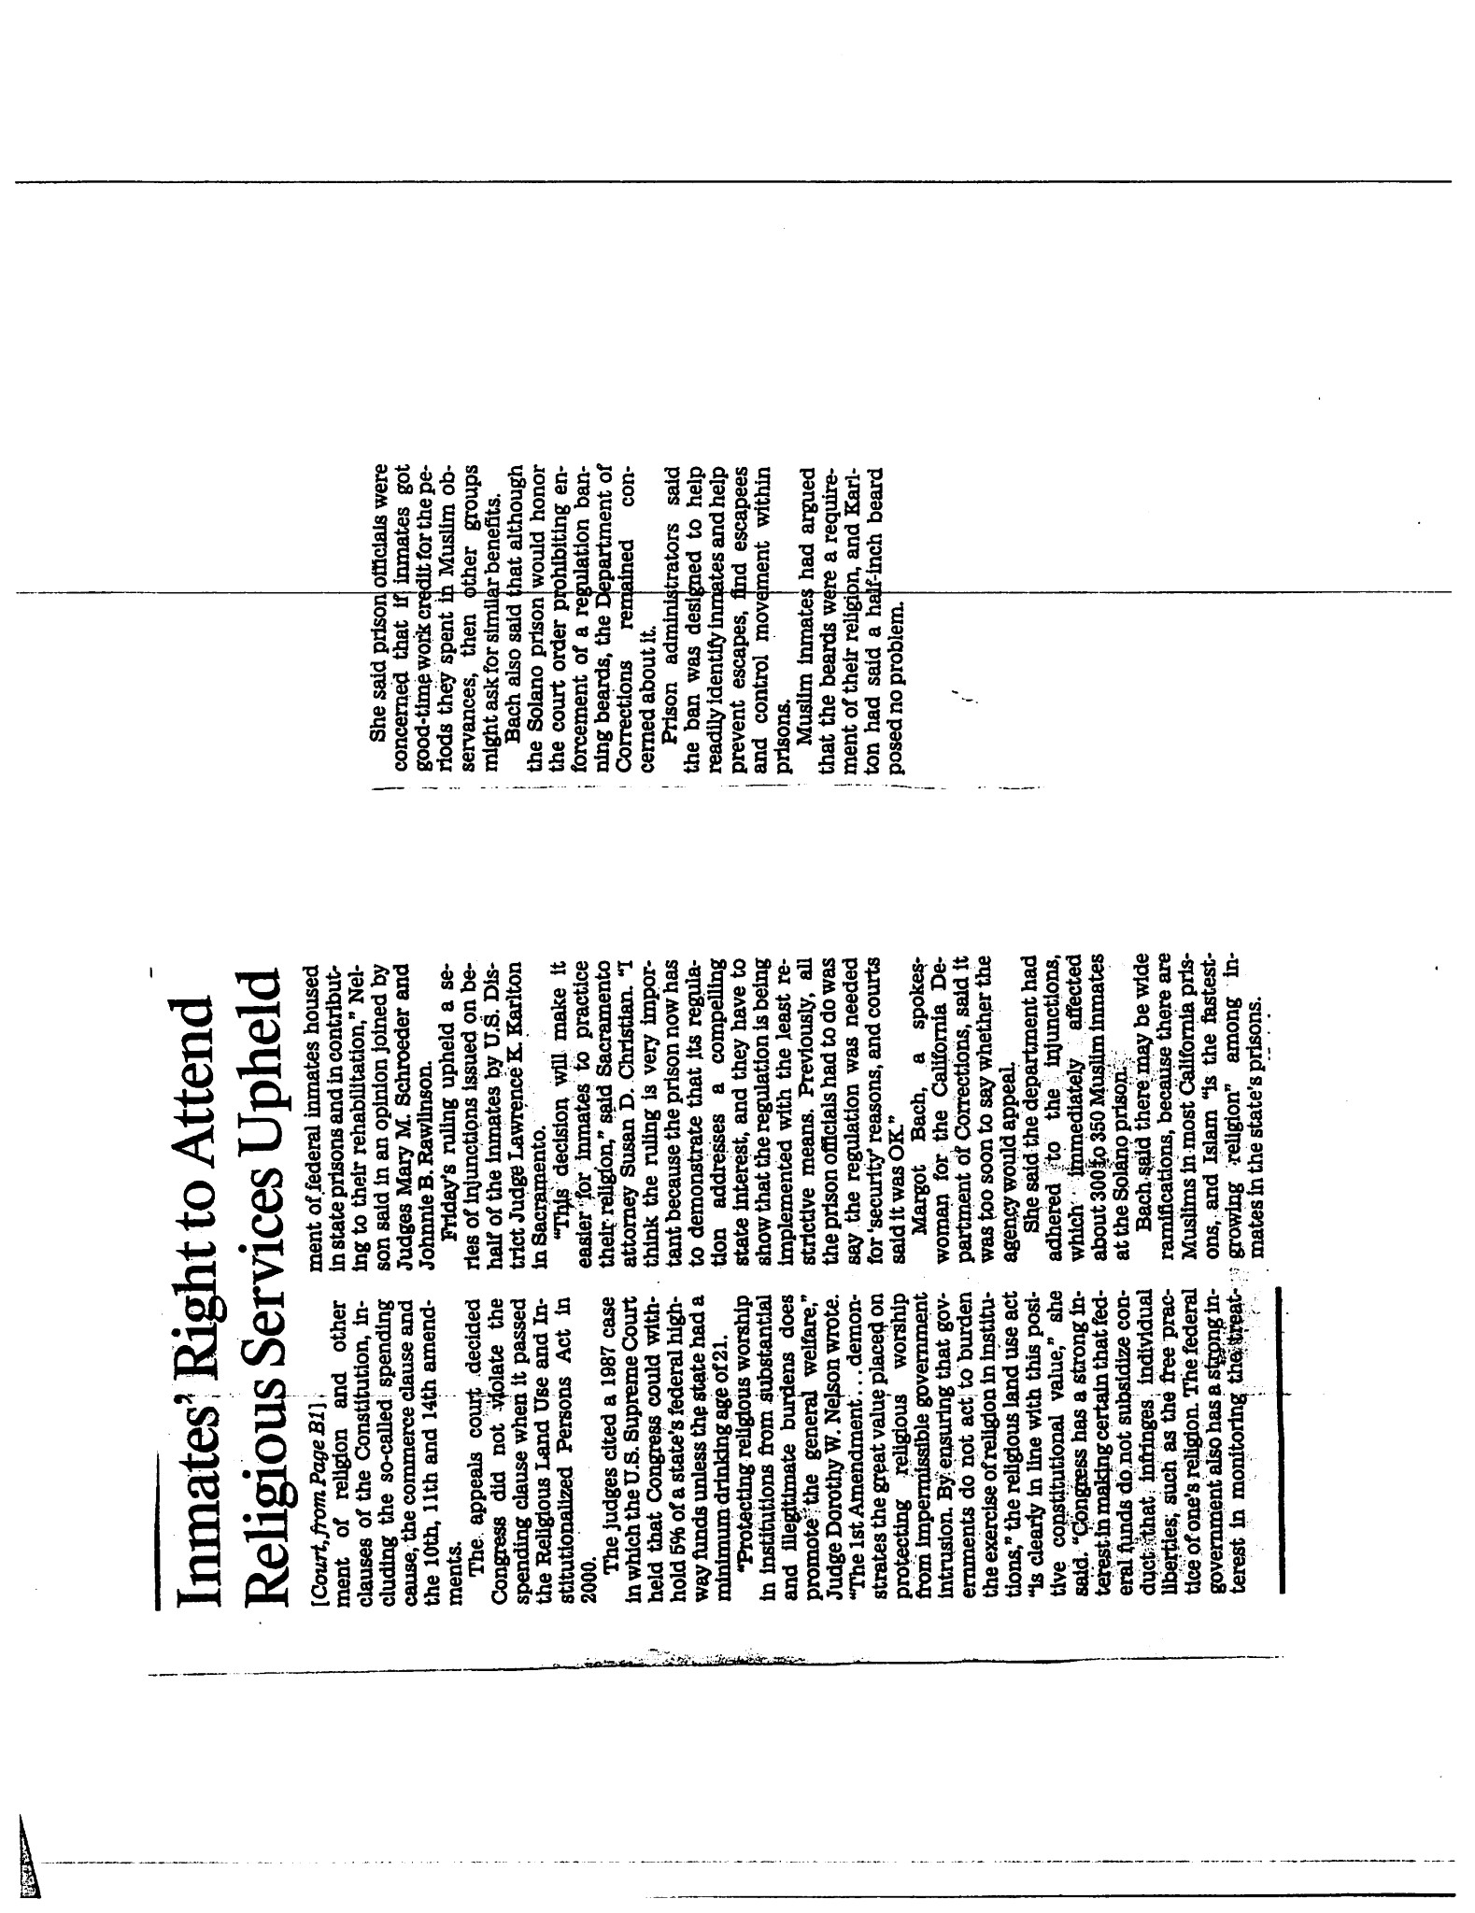
Form 22

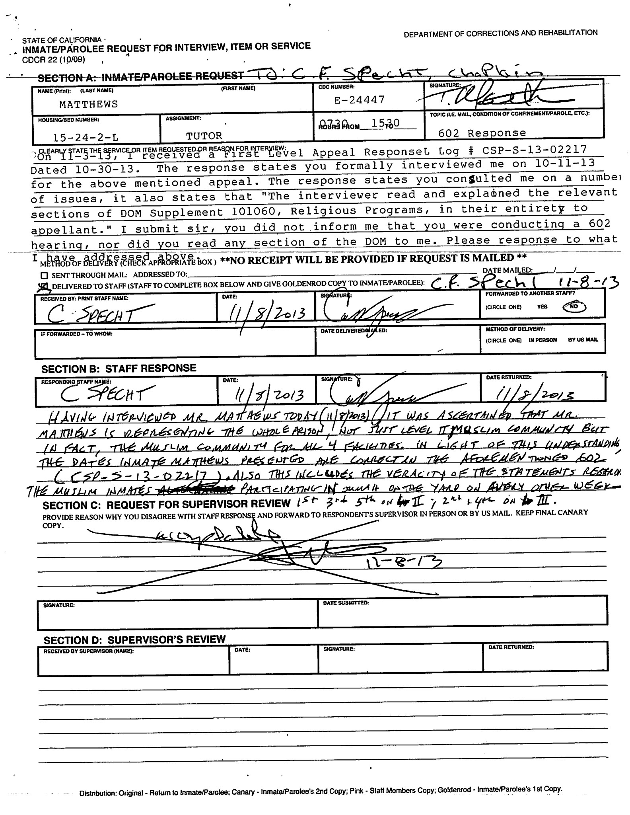

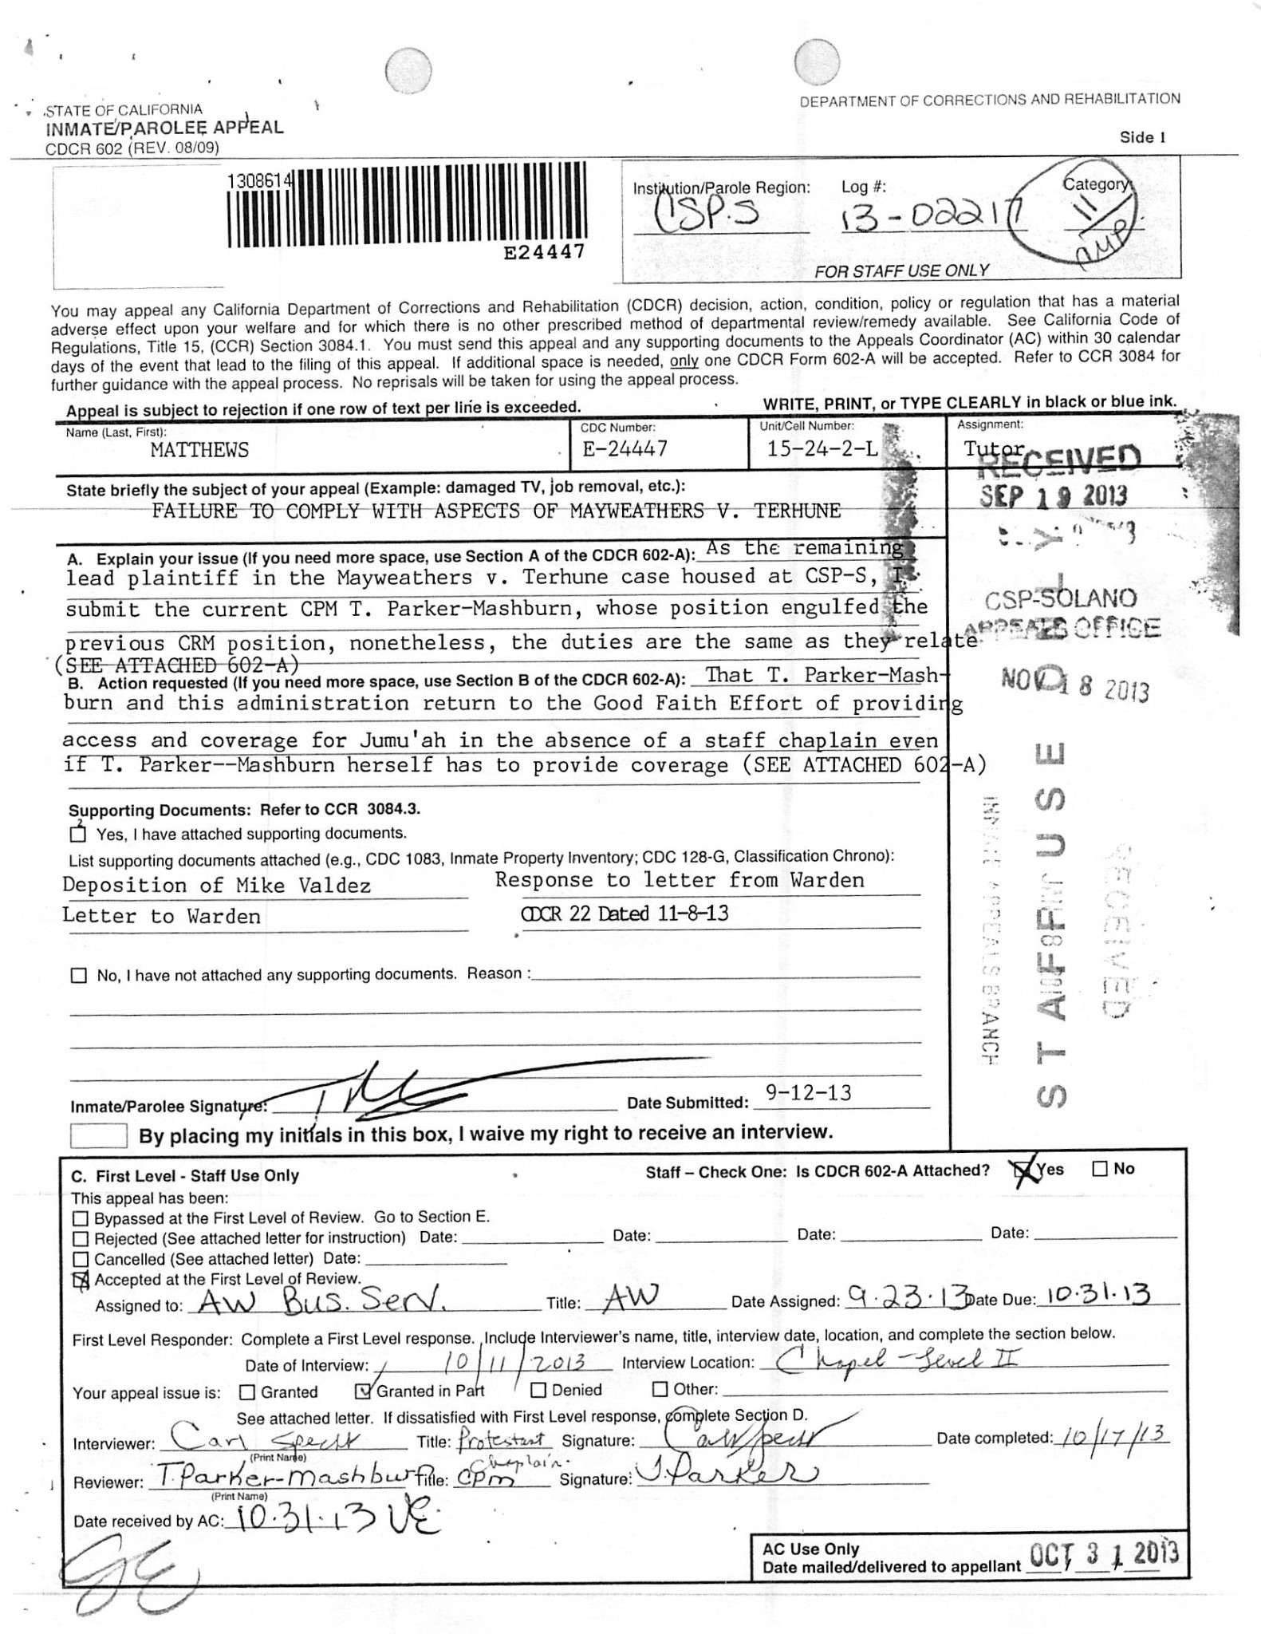
602/ 602-A/ 602-G

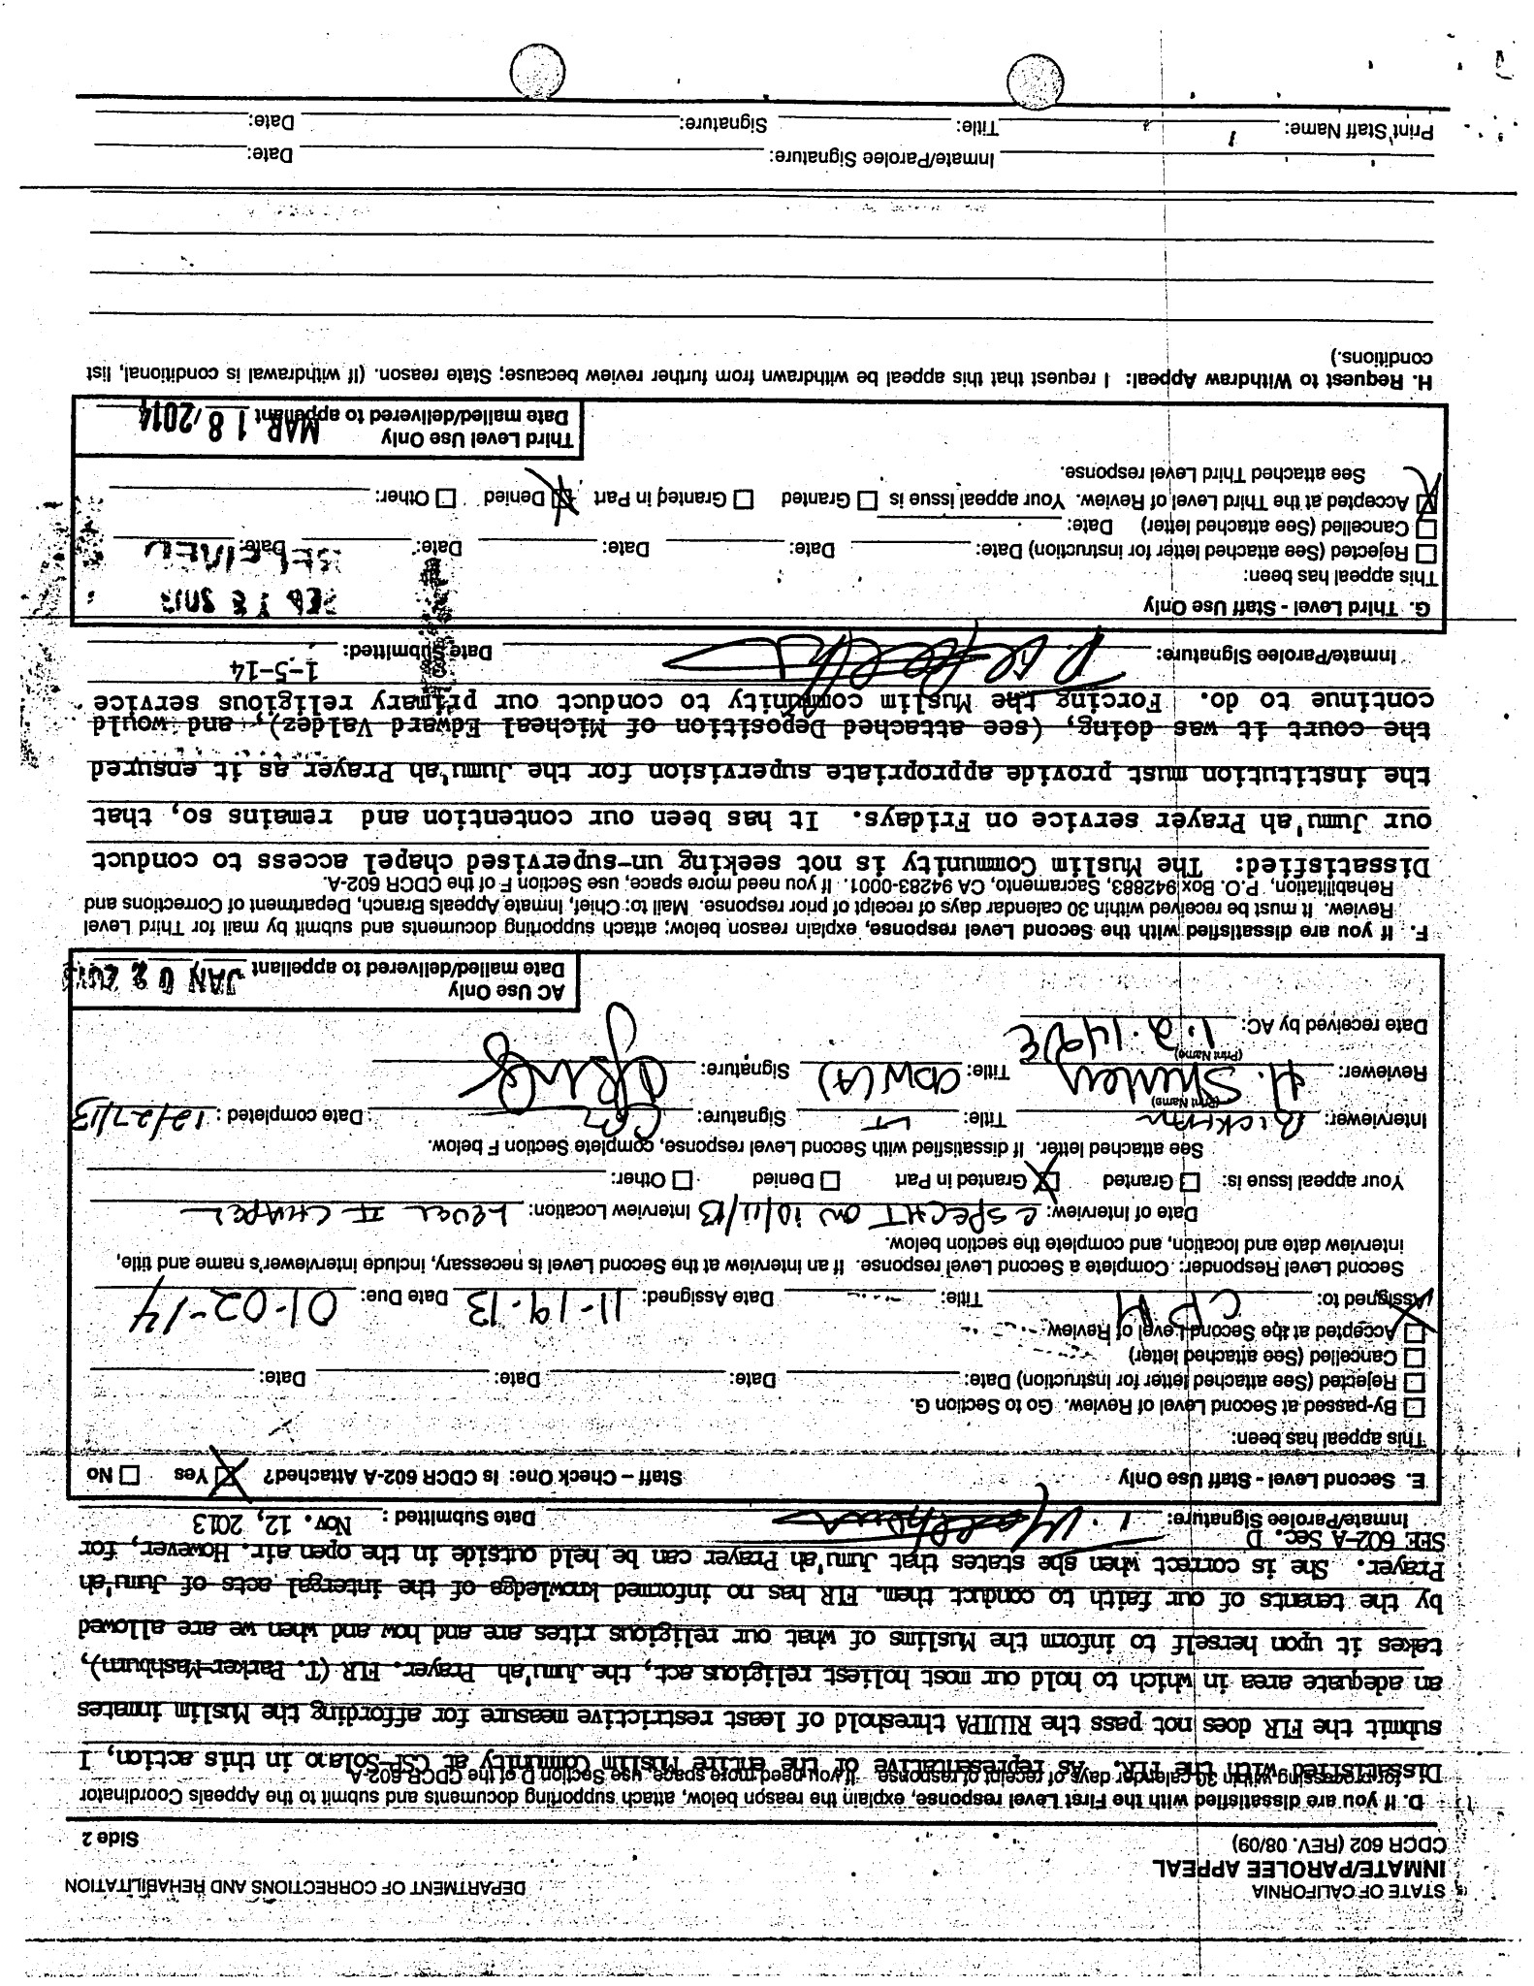

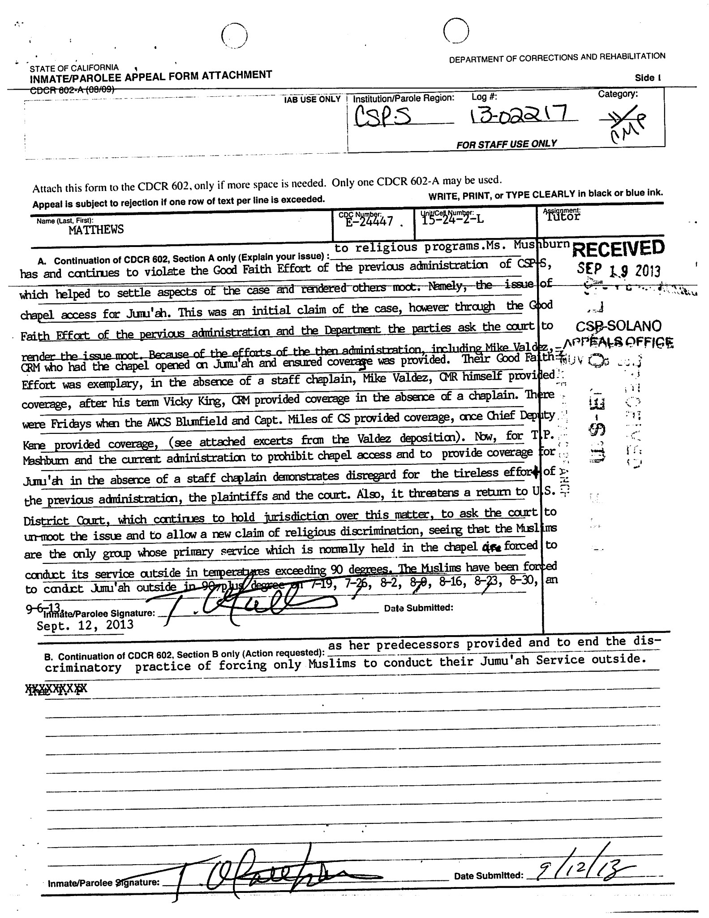

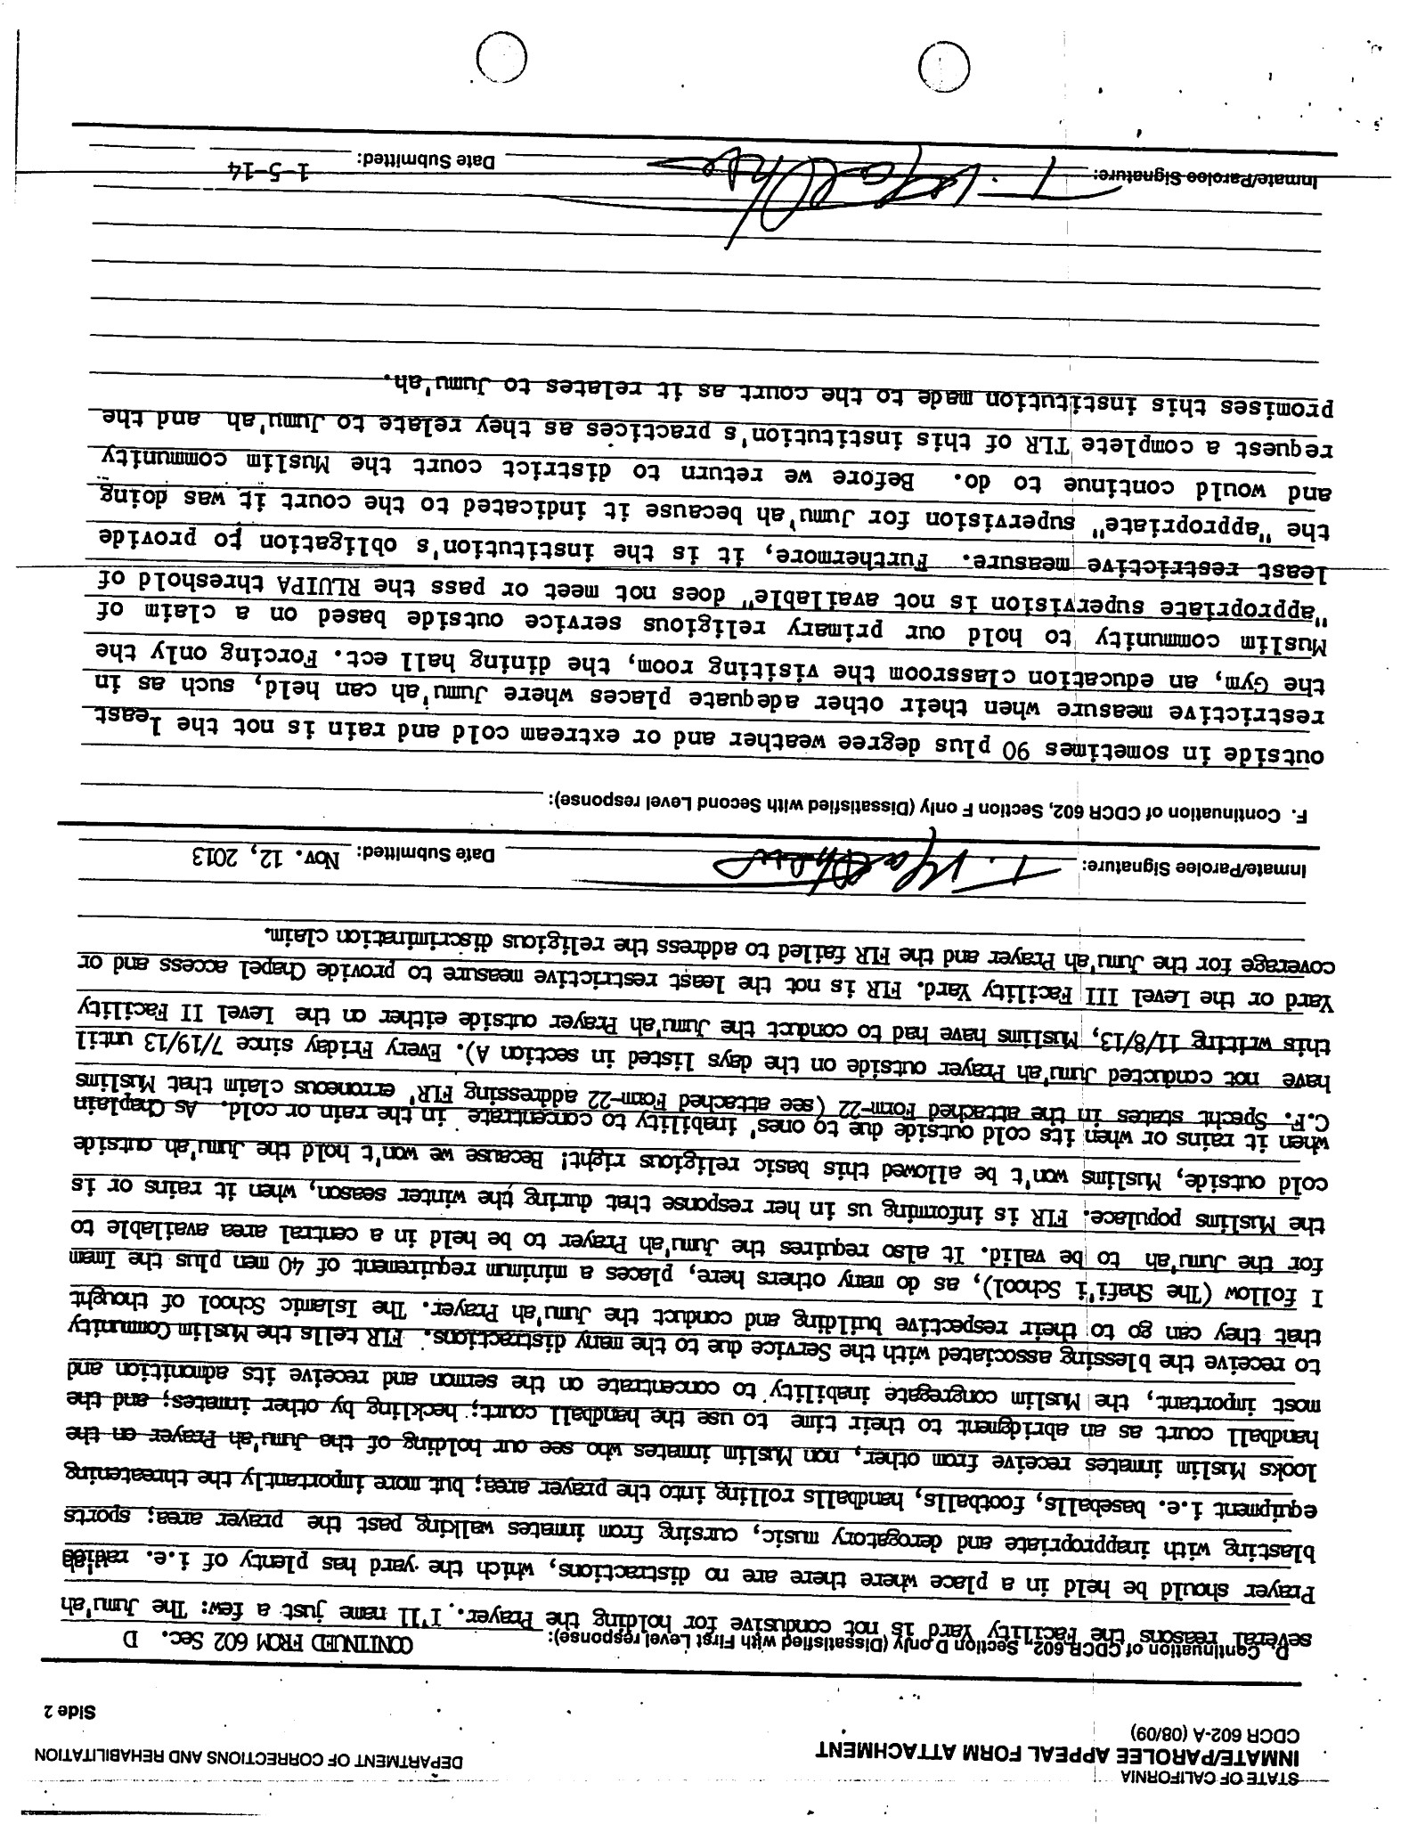

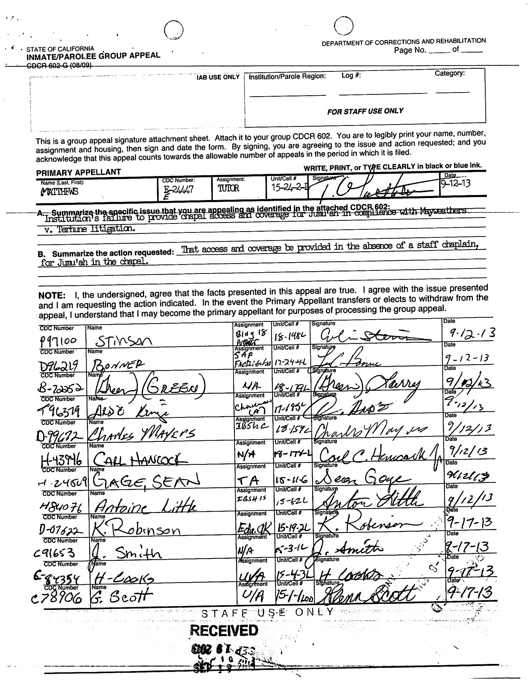

appeals Coordinator responses

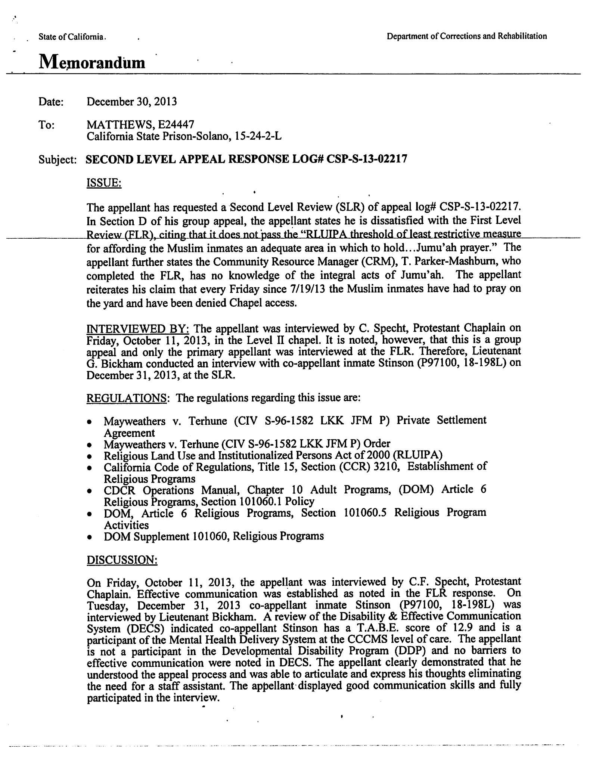
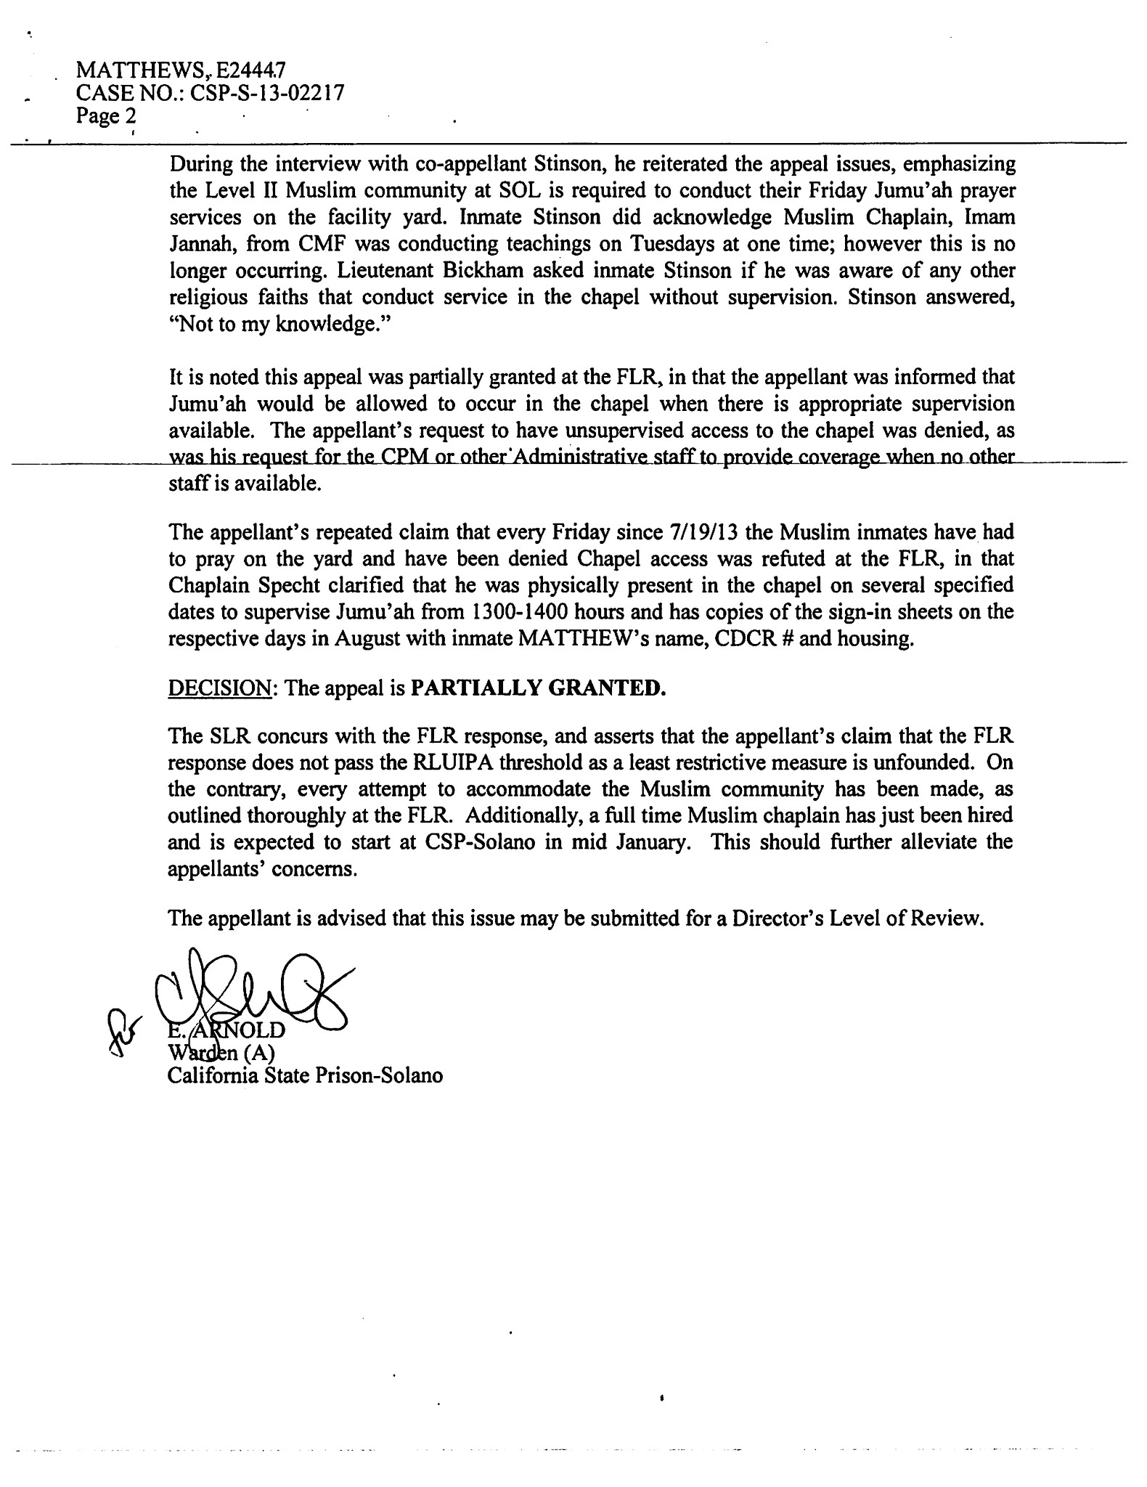

Appellant letter to warden
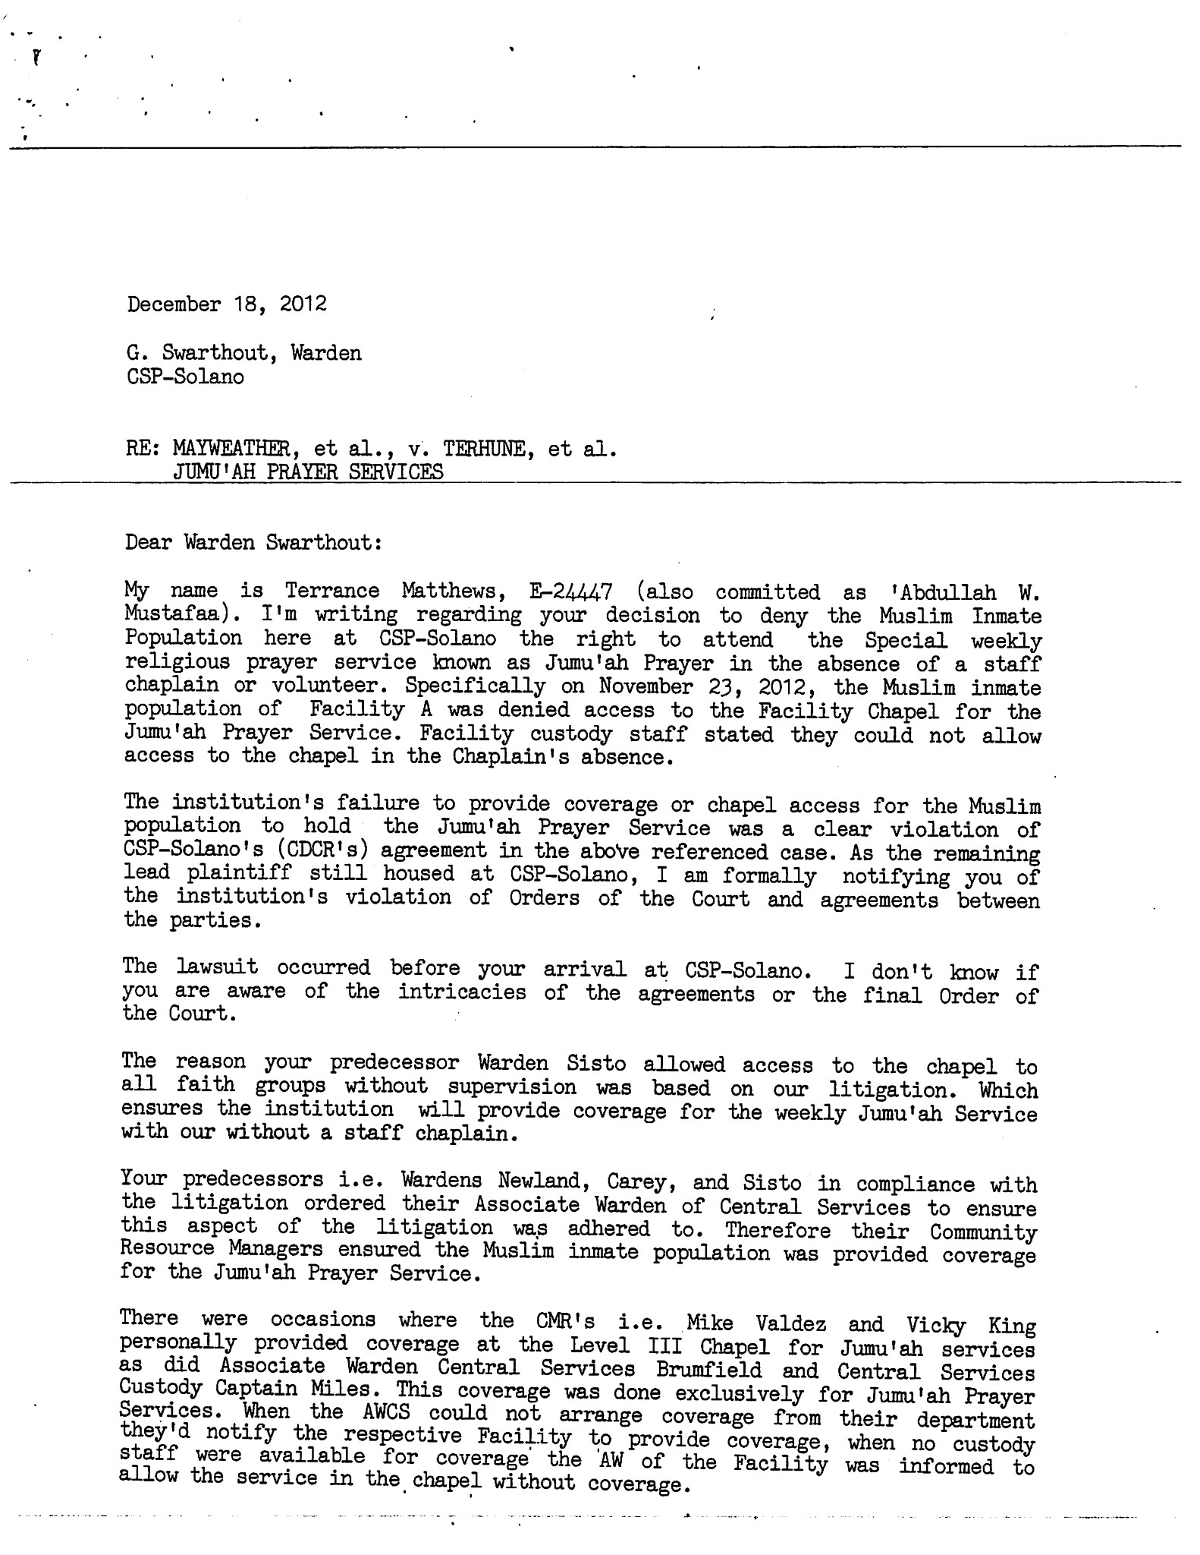

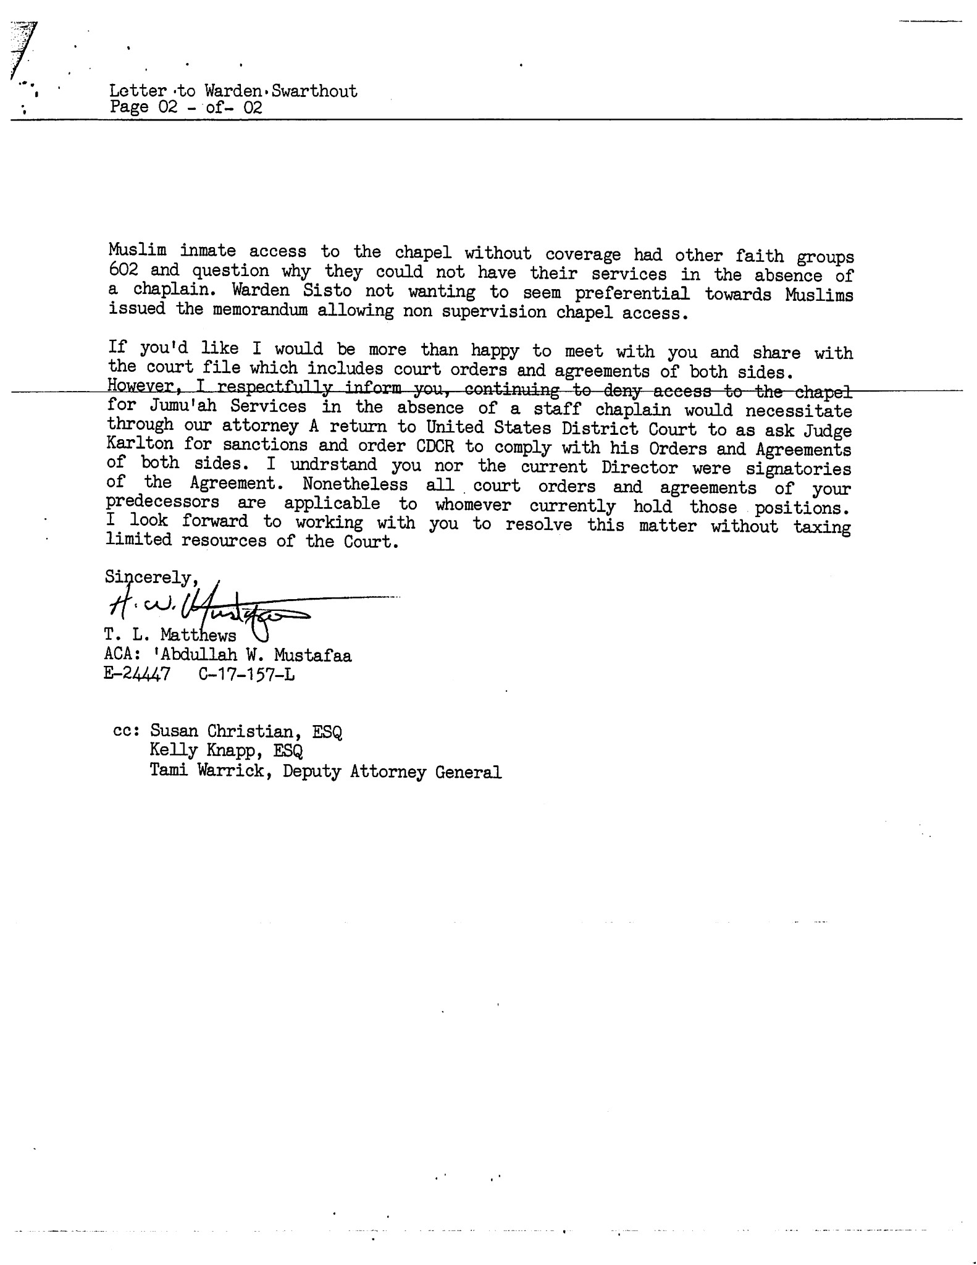

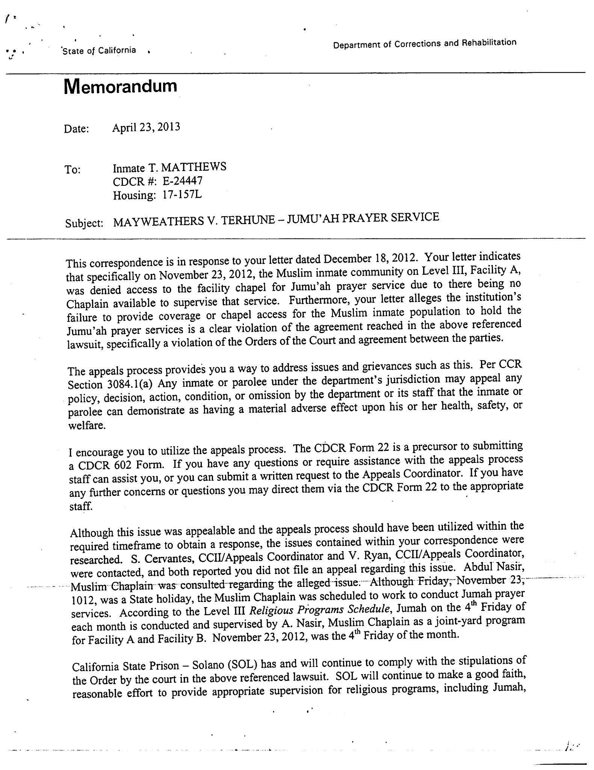
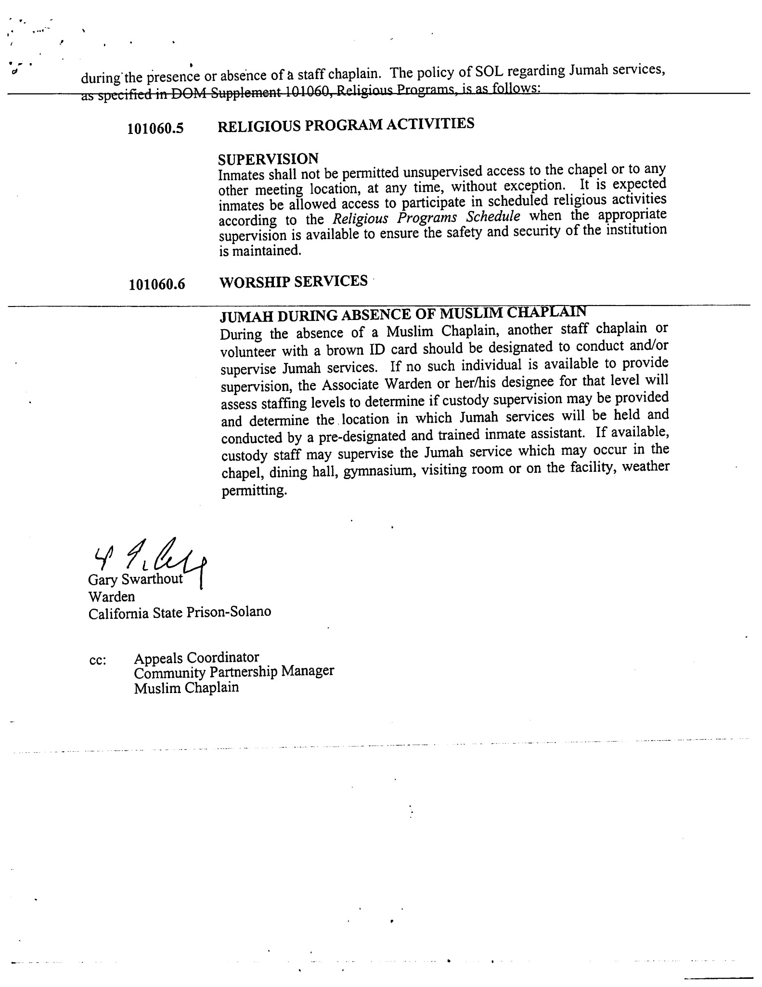

Supporting documents

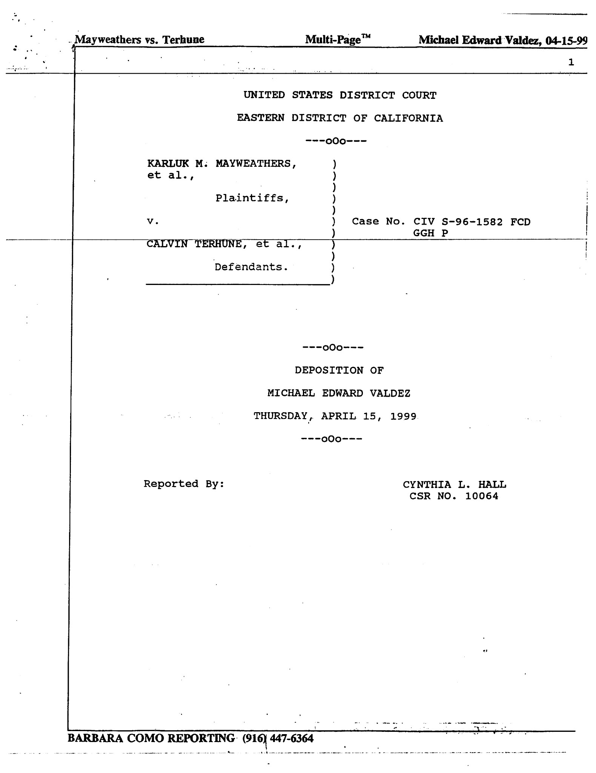

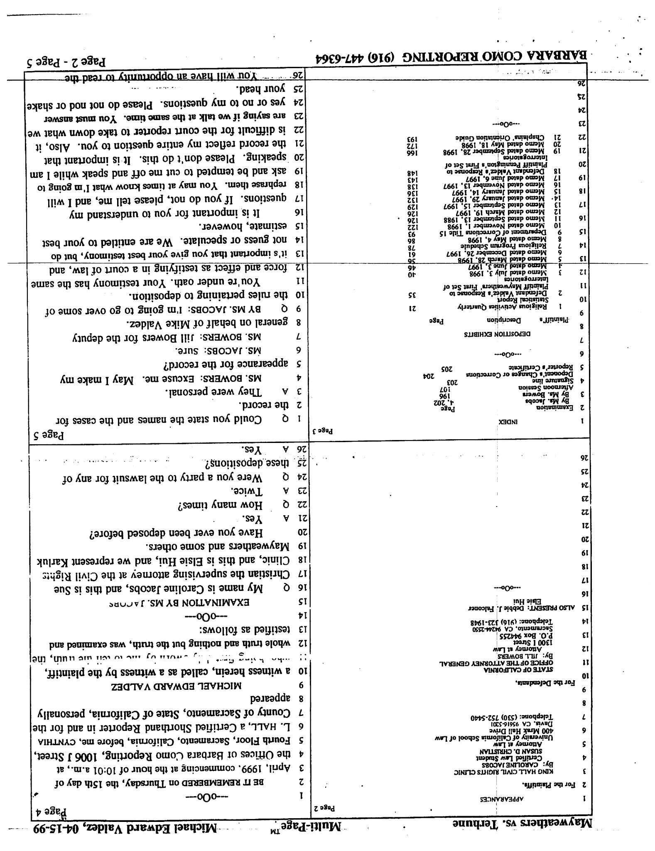

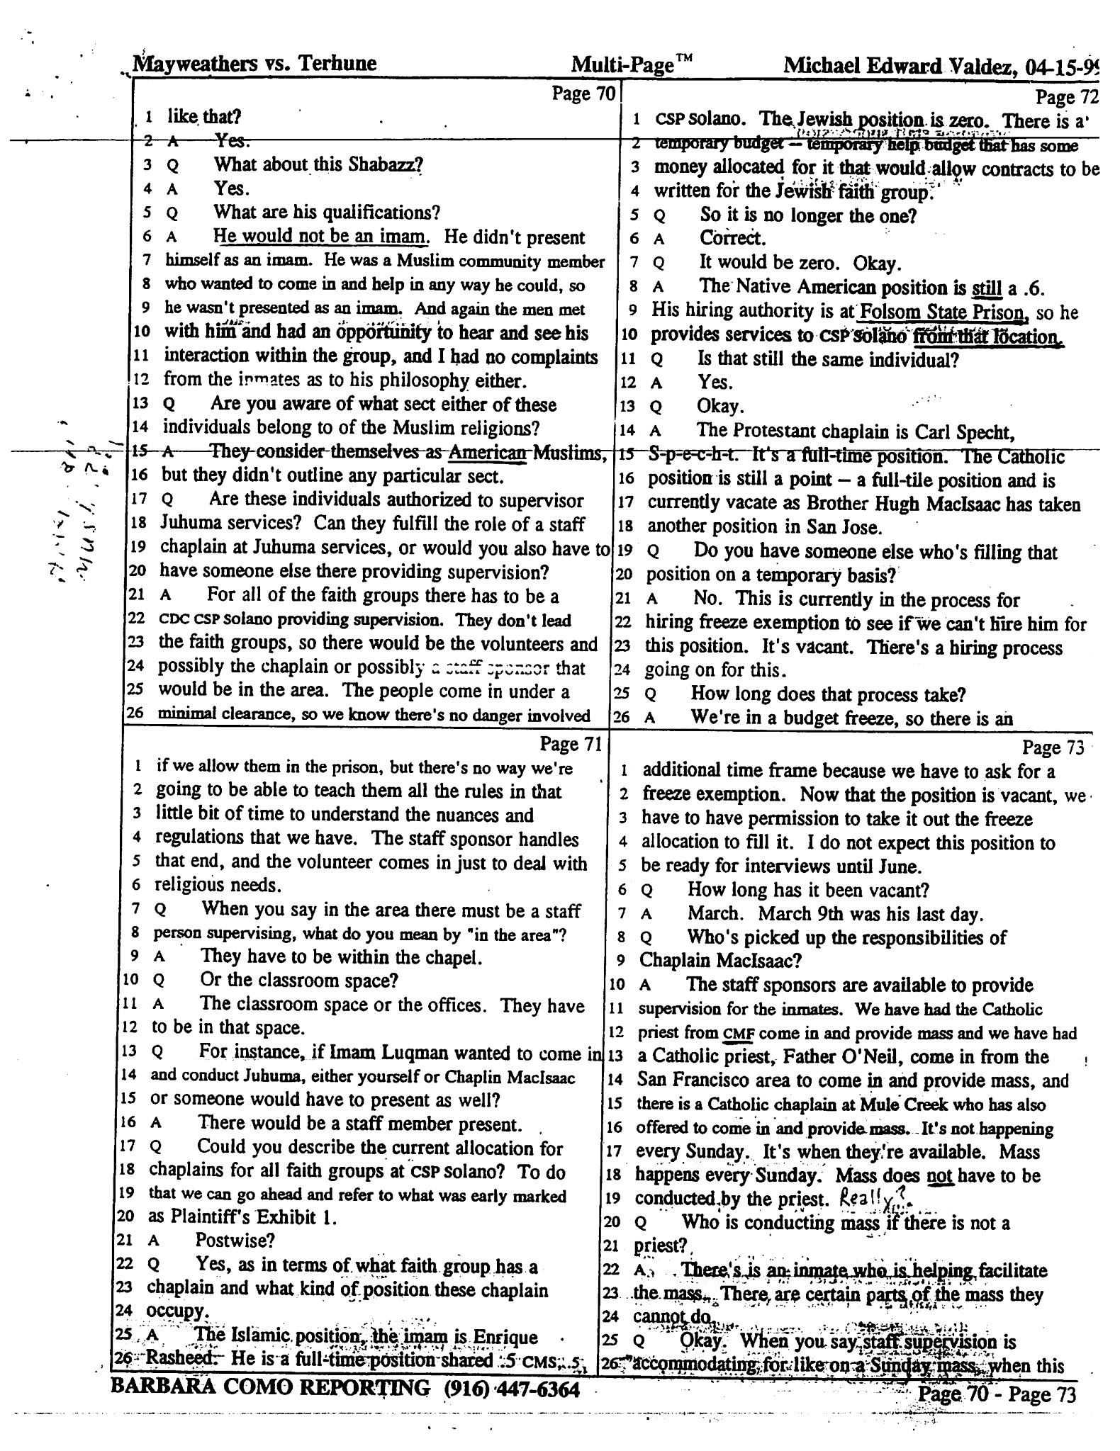

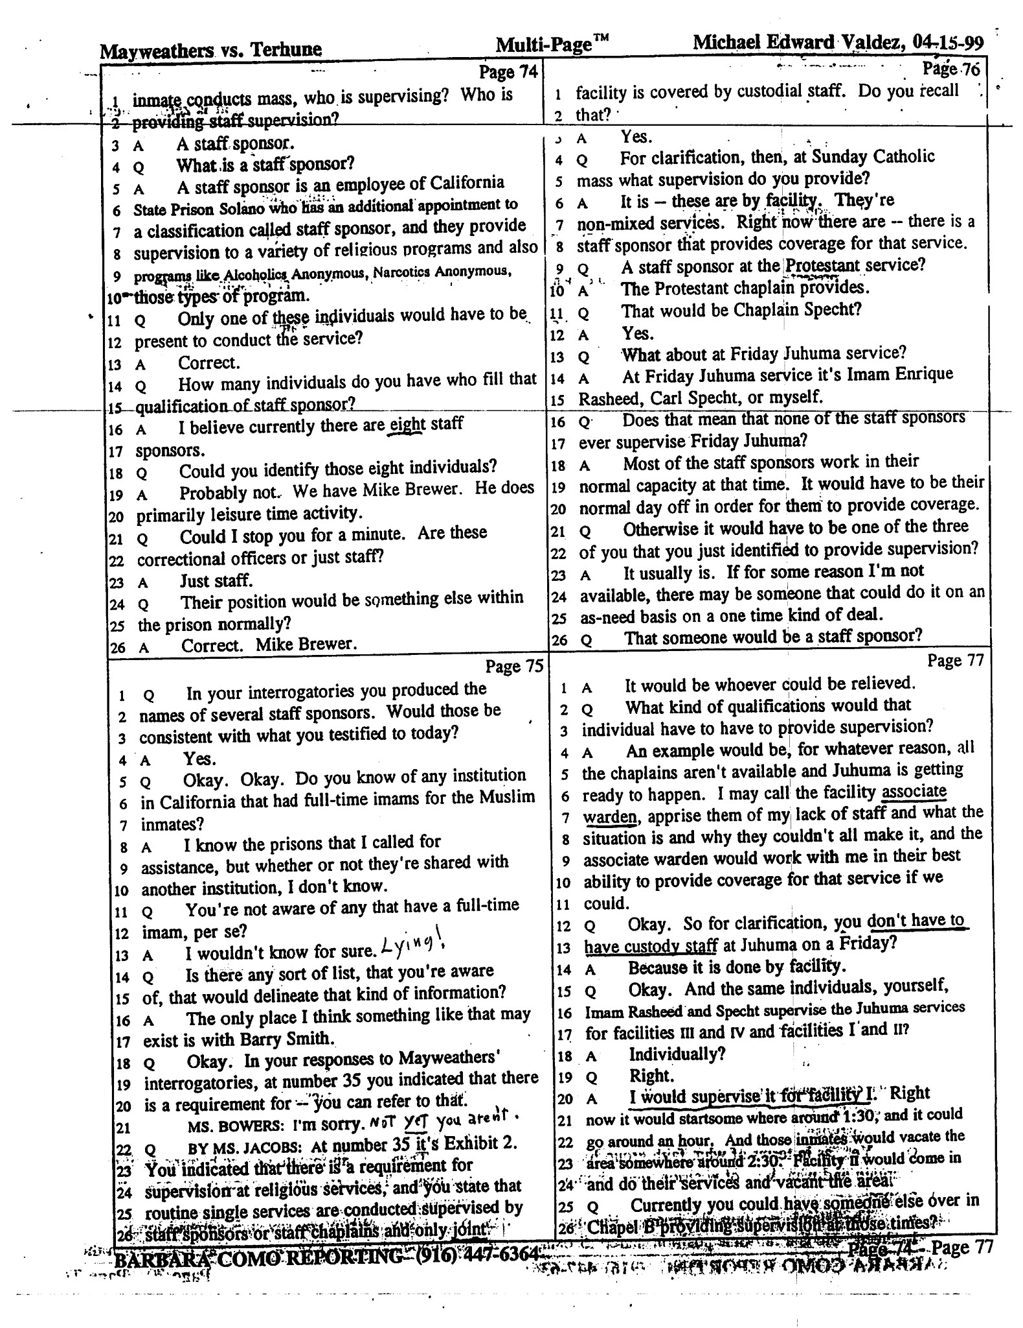

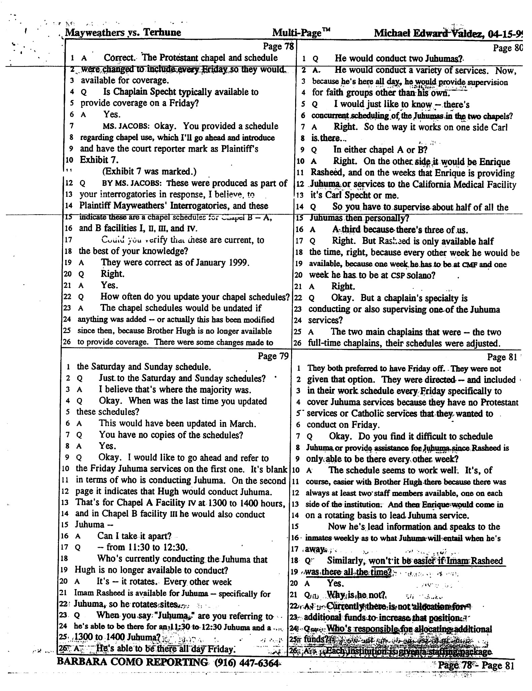

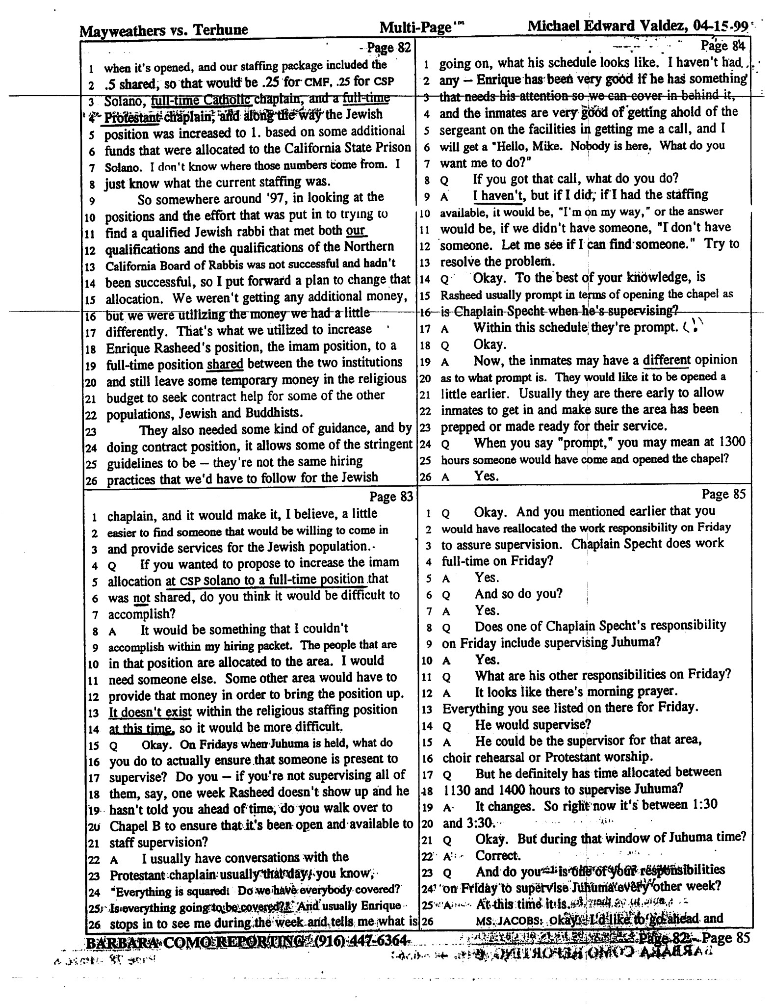

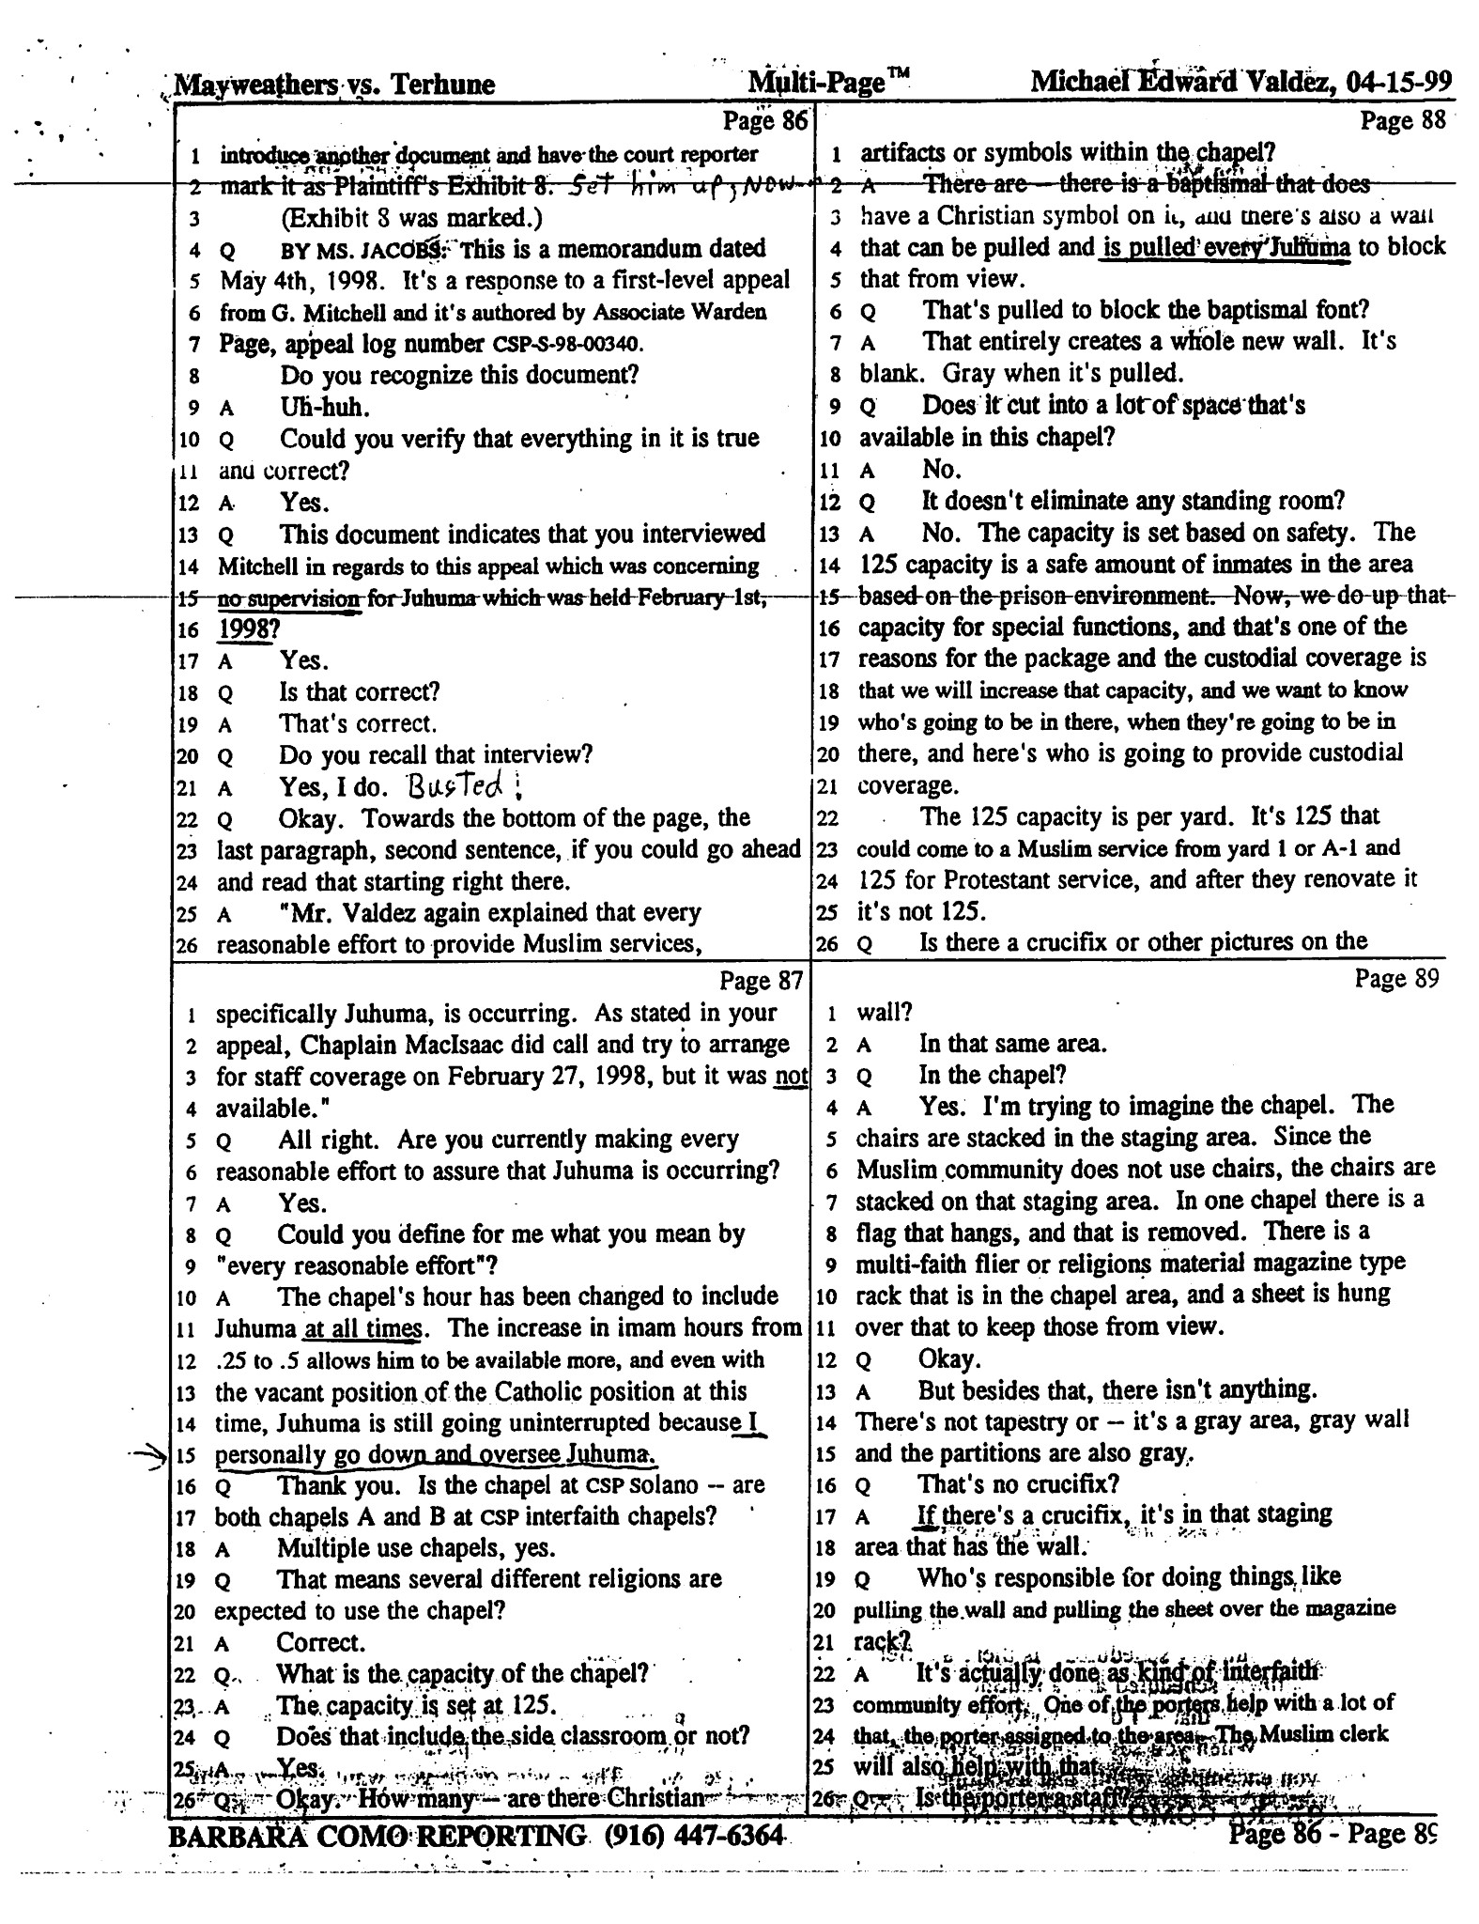

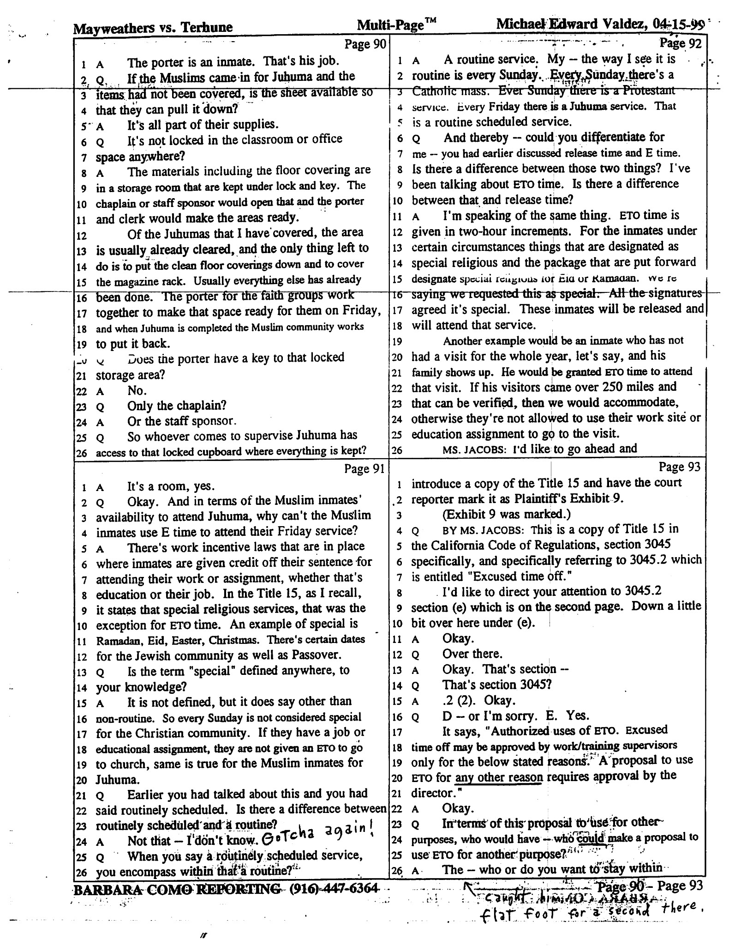

third level response
